## 1 https://stackoverflow.com/questions/75301106/not-being-able-to-display-button-in-reactjs

in order to render the Button, you have to render the component referencing it, in this case, MyApp.

## 2 <https://stackoverflow.com/questions/75250832/getting-unexpected-token-error-in-console-while-running-react>

JSX is not valid JavaScript, so it needs to be converted to valid JS. You can use a tool like [babel](https://babeljs.io/) to convert it to valid code.

– [code](https://stackoverflow.com/users/15359157/code)

[Jan 26 at 19:34](https://stackoverflow.com/questions/75250832/getting-unexpected-token-error-in-console-while-running-react#comment132788092_75250832)

* I never used babel so how do i go about?

– [Michael36](https://stackoverflow.com/users/19129298/michael36)

[Jan 26 at 19:35](https://stackoverflow.com/questions/75250832/getting-unexpected-token-error-in-console-while-running-react#comment132788113_75250832)

* 2

Did you use the create-react-app, or is this just in a plain html file?

– [Brenton Haerr](https://stackoverflow.com/users/12964542/brenton-haerr)

[Jan 26 at 19:42](https://stackoverflow.com/questions/75250832/getting-unexpected-token-error-in-console-while-running-react#comment132788222_75250832)

* Converted using babel and it worked-- "use strict"; const root = ReactDOM.createRoot(document.getElementById('root')); root.render( /*#__PURE__*/React.createElement("h1", null, "Hello, world!"));

– [Michael36](https://stackoverflow.com/users/19129298/michael36)

[Jan 26 at 19:45](https://stackoverflow.com/questions/75250832/getting-unexpected-token-error-in-console-while-running-react#comment132788269_75250832)

* i used just plain html file

– [Michael36](https://stackoverflow.com/users/19129298/michael36)

[Jan 26 at 19:45](https://stackoverflow.com/questions/75250832/getting-unexpected-token-error-in-console-while-running-react#comment132788281_75250832)

* 1

You can (for now) you can just use Babel standalone: [babeljs.io/docs/en/babel-standalone](https://babeljs.io/docs/en/babel-standalone)

– [code](https://stackoverflow.com/users/15359157/code)

[Jan 26 at 20:00](https://stackoverflow.com/questions/75250832/getting-unexpected-token-error-in-console-while-running-react#comment132788522_75250832)

## 3 <https://stackoverflow.com/questions/75046442/does-inline-block-not-respect-bottom-and-right-margins>

<p class="pick">hello1</p>

<p class="pick">hello2</p>

<p class="pick">hello3</p>

<div>1234</div>

body{

display: inline-block;

margin: 100px 10px 10px 90px;

/* top: 100 px margin */

/* right: 10 px margin */

/* bottom: 10 px margin */

/* left: 90 px margin */

}

<p>hello</p>

Are only top and left margins respected by inline-block elements ?I

you have nothing after the inline-block element to verify the effect of margin

– [Temani Afif](https://stackoverflow.com/users/8620333/temani-afif)

[Jan 8 at 8:42](https://stackoverflow.com/questions/75046442/does-inline-block-not-respect-bottom-and-right-margins#comment132433944_75046442)

* please explain with some example code

– [Michael36](https://stackoverflow.com/users/19129298/michael36)

[Jan 8 at 8:44](https://stackoverflow.com/questions/75046442/does-inline-block-not-respect-bottom-and-right-margins#comment132433959_75046442)

* if i change top and left margin values i can see changes being reflected in browser

– [Michael36](https://stackoverflow.com/users/19129298/michael36)

[Jan 8 at 8:47](https://stackoverflow.com/questions/75046442/does-inline-block-not-respect-bottom-and-right-margins#comment132433980_75046442)   Delete

* add more elements to your code

– [Temani Afif](https://stackoverflow.com/users/8620333/temani-afif)

[Jan 8 at 8:51](https://stackoverflow.com/questions/75046442/does-inline-block-not-respect-bottom-and-right-margins#comment132434015_75046442)

* added more elements to code and feel my question is wrong, pls confirm

– [Michael36](https://stackoverflow.com/users/19129298/michael36)

[Jan 8 at 10:04](https://stackoverflow.com/questions/75046442/does-inline-block-not-respect-bottom-and-right-margins#comment132434643_75046442)

for inline-block it doesnt matter

## 4 <https://stackoverflow.com/questions/74970812/why-do-we-need-to-use-a-calc-function-for-a-simple-operation-in-css>

n the [MDN web docs calc example](https://developer.mozilla.org/en-US/docs/Web/CSS/calc), I see a demo example with width: calc(10px + 100px) but I could instead simply use width: 110px.

So isn't calc(10px + 100px) complicating the code for a simple operation? How does calc really help me?

using calc is as you said, useless for two values of the same unit type, unless they're used through variables, e.g.:

:root {

--some-width: 50px;

}

.some-element {

width: calc(var(--some-width) + 100px);

}

Which would compute to 150px if --some-width is kept as 50px, however, --some-width can be changed to anything else, making the calc useful in this example - but useless in the provided example of calc(10px + 100px).

They're useful for combing relative units, such as em or % with other values (of irrelevant type).

See <https://developer.mozilla.org/en-US/docs/Learn/CSS/Building_blocks/Values_and_units> for relative length units.

The example of calc(10px + 100px) is as you said correctly, introducing more processing without any good reasoning, although not at a large scale.

## 5 <https://stackoverflow.com/questions/74775529/cant-select-values-using-html-u-a-tags-but-works-for-ahref>

a[href="https://cnn.com/"] {

color: red;

}

<a href="https://cnn.com/">cnn</a>

.r{

color: red;

}

<p>This is a <u>test</u> of the selection of u elements w JavaScript.</p>

<p>This is a <u class=r>test</u> of the selection of u elements w/o JavaScript.</p>

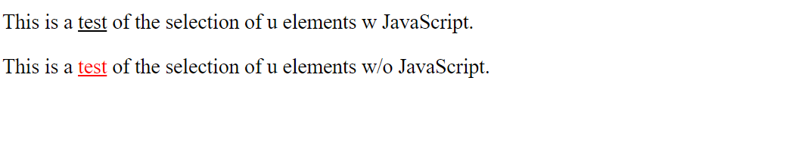

## 6 <https://stackoverflow.com/questions/74685136/how-to-reduce-letter-spacing-between-div-letters-h-2-o>

<!DOCTYPE html>

<html>

<head>

<style>

div {

display: block;

}

.sub1{

vertical-align: sub;

font-size:x-small;

}

</style>

</head>

<body>

<div>H<span class="sub1">2</span>O</div>

<div>CO<span class="sub1">2</span></div>

<div>SO<span class="sub1">4</span></div>

</div>

</body>

</html>

## 7 https://stackoverflow.com/questions/74618931/what-does-this-documentation-syntax-mean-in-mdn-for-inherit-css-tag

I have a basic question , refer to section as an example

Constituent properties in [list-style](https://developer.mozilla.org/en-US/docs/Web/CSS/list-style)

how do I interpret this statement of : inherit wherever it gets mentioned in mdn docs in a layman/ generic form? I also see Inherited value as Yes in Formal definition section so is it connected to :inherit in any way or not

<https://developer.mozilla.org/en-US/docs/Web/CSS/inherit>

The inherit CSS keyword causes the element to take the computed value of the property from its parent element. It can be applied to any CSS property, including the CSS shorthand property all.

1

how I can see the parent elements and the child elements visually in chrome browser?

– [Michael36](https://stackoverflow.com/users/19129298/michael36)

[Nov 29, 2022 at 19:00](https://stackoverflow.com/questions/74618931/what-does-this-documentation-syntax-mean-in-mdn-for-inherit-css-tag#comment131712089_74618974)

* 2

Open the page in Chrome, then press Ctrl-Shift-I to open the Developer tools and select the Elements tab. [Documentation](https://developer.chrome.com/docs/devtools/). If you have specific questions about Dev Tools, ask a new question.

What is role in CSS?

The role attribute **describes the role of an element in programs that can make use of it, such as screen readers or magnifiers**. Usage Example: <a href="#" role="button">Button Link</a> Screen Readers will read this element as “button” instead of “link”.13-Jan-2020

## 8 <https://stackoverflow.com/questions/74598383/why-does-displayinline-in-ul-css-tag-causes-elements-to-shift>

[why does display:inline in ul css tag causes elements to shift](https://stackoverflow.com/questions/74598383/why-does-displayinline-in-ul-css-tag-causes-elements-to-shift)

ul{display: inline;}

<ul>hi

<li>1234</li>

<li>5678</li>

</ul>

<ul>hello

<li>abcdef</li>

<li>ghijkl</li>

</ul>

## 9 question:the ul items(hi,hello) in above css code moved a couple of places to the right if I used the css display:inline tag . But They do not get moved if I execute with a css ul tag having no display:inline value..please explain. and second question why have the circle markers disappeared ?

answer1:

li elements have a display value equal to list-item and following [the specification](https://w3c.github.io/csswg-drafts/css-display/#the-display-properties) they generate a block box so you end having **a block element inside and inline element**.

The above behavior is also defined in the specification and leads to the result you get. More detail: [Is it wrong to change a block element to inline with CSS if it contains another block element?](https://stackoverflow.com/q/746531/8620333)

**why have the circle markers disappeared?**

It's still there but hidden on the left because the default behavior is list-style-position: outside

ul{display: inline;}

li {margin-left: 20px;}

<ul>hi

<li>1234</li>

<li>5678</li>

</ul>

<ul>hello

<li>abcdef</li>

<li>ghijkl</li>

</ul>

aNs2:

ul gets a default padding-left applied from the user agent stylesheet, 40px or something.

With an inline element, padding-left works only before the first line of content, and padding-right only after the last line.

Make it inline-block instead, if you want that padding applied to the whole element.

Ans3:

Because the **inline** value of the **display** property is something that makes the elements inside to behaves inline.

That means you have not much options to position and move them.

The **inline** value is most useful for text paragraph to wrap the entire paragraph. Where you would like the text to position in a couple of lines one below another.

## 10 [Children don't inherit style despite declaration on ancestor](https://stackoverflow.com/questions/74591932/children-dont-inherit-style-despite-declaration-on-ancestor)

<https://stackoverflow.com/questions/74591932/children-dont-inherit-style-despite-declaration-on-ancestor>

I declared display: inline on body but the elements are still displayed in block fashion. Please help me understand the concept.

Declaring display: inline directly on li works: They will display in inline fashion. But why doesn't inline apply to them when declaring on body?

body {display: inline}

<body>

<ul>

<li>1234</li>

<li>5678</li>

</ul>

</body>

 Comment:

I also tried with display: inherit on li, but it still displays in block fashion, and also removes the markers which I don't want:

body {display: inline}

li {display: inherit}

<body>

<ul>

<li>1234</li>

<li>5678</li>

</ul>

</body>

* Answer:

display is not inherited: Setting the <BODY> to display: inline won't affect its children's display value.

– [Oskar Grosser](https://stackoverflow.com/users/13561410/oskar-grosser)

[Nov 27, 2022 at 17:00](https://stackoverflow.com/questions/74591932/children-dont-inherit-style-despite-declaration-on-ancestor#comment131665780_74591932)

f I wanna display inline to be inhertiable by all the children's display value ,then what would be the code?. I tried <style> body { display: inline; } li { display: inherit; } </style> but it still shows in BLOCK

– [Michael36](https://stackoverflow.com/users/19129298/michael36)

Setting display on an element will not have its children inherit the value:

.wrapper {display: inline}

<div class="wrapper">

<div>First text.</div>

<div>Second text.</div>

</div>

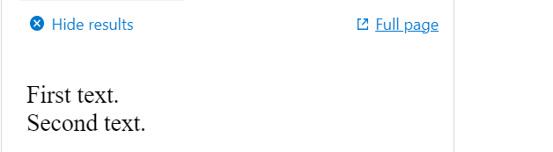

While you can declare elements to inherit display from their ancestors, I do not recommend this (generally):

* Declaring elements to inherit display requires a declaration just as much as declaring a specific display value.
* If the selector is too unspecific, elements with sensible default values will lose those values.

It is important to choose good selectors for your use case. For your short example it is fine to have a generic selector, like body * (in words: "All descendants of BODY") which uses the [universal selector *](https://developer.mozilla.org/en-US/docs/Web/CSS/Universal_selectors) and a [descendant combinator](https://developer.mozilla.org/en-US/docs/Web/CSS/Descendant_combinator) .

**Note:** Using a combinator generally does not select "sub-selections" itself, e.g. BODY of selector body * will not be selected. Also note that the *descendant combinator* is less specific than the [child combinator >](https://developer.mozilla.org/en-US/docs/Web/CSS/Child_combinator).

Here is an analogous example: **also note difference between .wrapper {display: inline}**

**And .wrapper * {display: inline}**

.wrapper * {display: inline}

<div class="wrapper">

<div>First text.</div>

<div>Second text.</div>

</div>

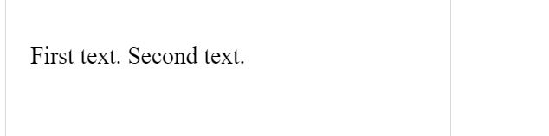

If however you still want to declare the elements to *inherit* display, here is an example:

.wrapper {display: inline} /*Set the value to inherit*/

.wrapper * {display: inherit}

<div class="wrapper">

<div>First text.</div>

<div>Second text.</div>

</div>

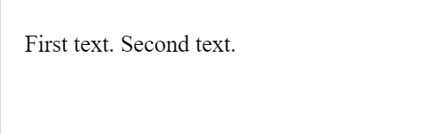

Lists and display

Lists' default display value is block, and the value of its children (LI) is list-item. If you simply want to get rid of the markers, declare the list list-style-type: none:

ul {list-style-type: none}

<ul>

<li>First item.

<li>Second item.

</ul>

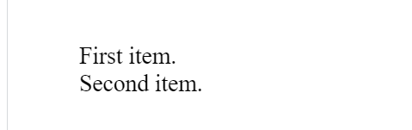

But you can also declare the list and its children (ul, ul>*) as display: inline. Note that removing padding requires another declaration.

ul, ul>* {display: inline}

<ul>

<li>First item.

<li>Second item.

</ul>

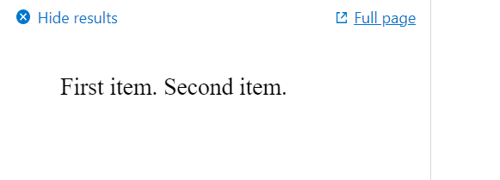  
  
  
Inline list with markers

If you want to inline the list-items with markers, there are several possibilities:

You can keep [::marker](https://developer.mozilla.org/en-US/docs/Web/CSS/::marker)s of inline list-items by declaring the [list as display: inline-flex](https://stackoverflow.com/a/69368934/13561410).

**Sidenote:** ::markers are by default [outside](https://developer.mozilla.org/en-US/docs/Web/CSS/::marker) the list-item's [principal box](https://stackoverflow.com/a/69368934/13561410), which means they can obstruct view of other boxes. Declare the list (or its items) as [list-style-position: inside](https://developer.mozilla.org/en-US/docs/Web/CSS/flex-wrap#nowrap) to keep the markers inside the list-item's box to prevent such overflow.

**Note** that [flex-wrap: nowrap](https://developer.mozilla.org/en-US/docs/Web/CSS/flex-wrap#nowrap) is its default, which is unlike regular text flow. Use [flex-wrap: wrap](https://developer.mozilla.org/en-US/docs/Web/CSS/flex-wrap#wrap) to have the list-items (and their content) flow like regular text:

// Ignore; for handling radio inputs

const form = document.querySelector("form");

const list = document.querySelector("ol");

form.addEventListener("input", evt => {

const className = evt.target.name === "position" ? "inside" : "wrap";

// Classes for applying non-default values are named after the values

const state = evt.target.value === className;

list.classList.toggle(className, state);

});

ol {display: inline-flex}

.inside {list-style-position: inside}

.wrap {flex-wrap: wrap}

/*Ignore; for presentational purposes*/

ol {margin: 0; padding: 0}

li {border: 1px solid darkgray}

section {margin-block: 1.2rem}

<form>

<div>

List type:

<label for="i-outside">

<input id="i-outside" name="position" type="radio" value="outside" checked> Outside

</label>

<label for="i-inside">

<input id="i-inside" name="position" type="radio" value="inside"> Inside

</label>

</div>

<div>

Wrapping:

<label for="i-nowrap">

<input id="i-nowrap" name="wrap" type="radio" value="nowrap" checked> No-wrap

</label>

<label for="i-wrap">

<input id="i-wrap" name="wrap" type="radio" value="wrap"> Wrap

</label>

</div>

</form>

<ol>

<li>A very long named item that hopefully overflows its box, and

<li>An item, and

<li>Another short item, and

<li>another very long named item that too should overflow its box.

</ol>

**List-items don't inherit display?**

You asked why the following didn't result in the LIs to inherit the BODY's display value:

body {display: inline}

li {display: inherit}

<body>

<ul>

<li>First item.

<li>Second item.

</ul>

</body>

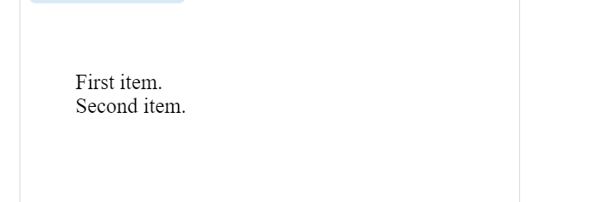

That is because—while BODY is declared as display: inline—the list(ol) in between has the default display value of block. Since inheritance happens from the element's immediate ancestor, the list-items will inherit the value block from the list

## 11 [Tailwind css design concept and implementation](https://stackoverflow.com/questions/74559160/tailwind-css-design-concept-and-implementation)

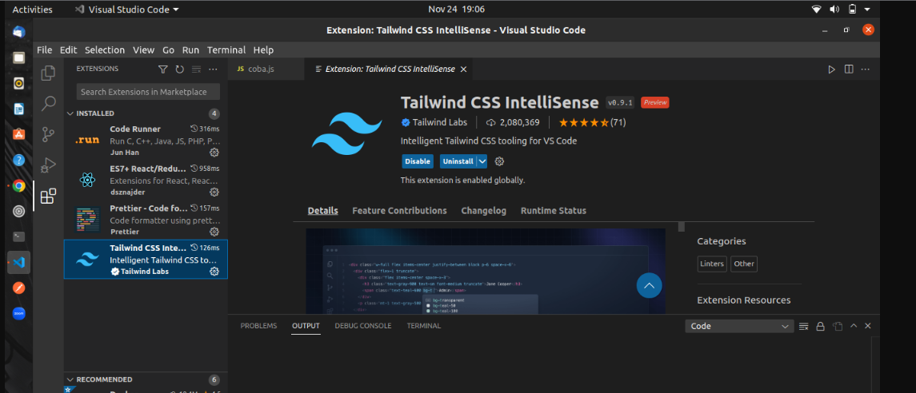

## 12 [scss : the ampersand css operator is not working for my html page](https://stackoverflow.com/questions/74292937/scss-the-ampersand-css-operator-is-not-working-for-my-html-page)

a {

&:visited {

color: cyan;

}

&:hover {

color: orangered;

}

}

<h1>CSS operator</h1>

<dl>

<dt><a href="https://getbootstrap.com/">Bootstrap CSS Home page</a></dt>

<dd>BOOTSTRAP CSS</dd>

<dt><a href= "https://docs.python.org/3/howto/sorting.html#sortinghowto">Sorting</a></dt>

<dd>Python Sorting</dd>

</dl>

 Run code snippet

Expand snippet

Issue regarding the & CSS operator and pseudo selector:

(1) If I am hovering over the a href link for say BOOTSTRAP CSS, it is not changing color to orangered as per  
&:hover {color: orangered;}

(2) The link color is not changing to cyan after I visit the ahref link(click) as per: &:visited {color: cyan;}

* [html](https://stackoverflow.com/questions/tagged/html)
* [css](https://stackoverflow.com/questions/tagged/css)
* [sass](https://stackoverflow.com/questions/tagged/sass)
* 3

You cannot run scss in browser you need to compile it to standard css

– [kennarddh](https://stackoverflow.com/users/14813577/kennarddh)

[Nov 2, 2022 at 16:57](https://stackoverflow.com/questions/74292937/scss-the-ampersand-css-operator-is-not-working-for-my-html-page#comment131161782_74292937)

* how to do that? if possible can you send some documentation links

– [Michael36](https://stackoverflow.com/users/19129298/michael36)

[Nov 2, 2022 at 16:58](https://stackoverflow.com/questions/74292937/scss-the-ampersand-css-operator-is-not-working-for-my-html-page#comment131161818_74292937)

You can read about scss and sass [here](https://sass-lang.com/)

– [kennarddh](https://stackoverflow.com/users/14813577/kennarddh)

[Nov 2, 2022 at 16:59](https://stackoverflow.com/questions/74292937/scss-the-ampersand-css-operator-is-not-working-for-my-html-page#comment131161834_74292937)

## 13 [why does Javascript force me to use a IFFE sometimes [duplicate]](https://stackoverflow.com/questions/73996350/why-does-javascript-force-me-to-use-a-iffe-sometimes)

https://stackoverflow.com/questions/8228281/what-is-the-function-construct-in-javascript

It’s an [Immediately-Invoked Function Expression](http://benalman.com/news/2010/11/immediately-invoked-function-expression/), or [**IIFE**](https://en.wikipedia.org/wiki/Immediately-invoked_function_expression) for short. It executes immediately after it’s created.

It has nothing to do with any event-handler for any events (such as document.onload).  
Consider the part within the first pair of parentheses: (**function(){}**)();....it is a regular function expression. Then look at the last pair (function(){})**()**;, this is normally added to an expression to call a function; in this case, our prior expression.

This pattern is often used when trying to avoid polluting the global namespace, because all the variables used inside the IIFE (like in any other normal function) are not visible outside its scope.  
This is why, maybe, you confused this construction with an event-handler for window.onload, because it’s often used as this:

(function(){

// all your code here

var foo = function() {};

window.onload = foo;

// ...

})();

// foo is unreachable here (it’s undefined)

**Correction suggested by**[**Guffa**](https://stackoverflow.com/users/69083/guffa)**:**

The function is executed right after it's created, not after it is parsed. The entire script block is parsed before any code in it is executed. Also, parsing code doesn't automatically mean that it's executed, if for example the IIFE is inside a function then it won't be executed until the function is called.

**Update** Since this is a pretty popular topic, it's worth mentioning that IIFE's can also be written with [ES6's arrow function](https://developer.mozilla.org/en-US/docs/Web/JavaScript/Reference/Functions/Arrow_functions) (like [Gajus](https://stackoverflow.com/users/368691/gajus) has pointed out [in a comment](https://stackoverflow.com/questions/8228281/what-is-the-function-construct-in-javascript/8228308#comment43521302_8228308)) :

((foo) => {

// do something with foo here foo

})('foo value')

console.log("==PARALLEL with await Promise.all==");

parallel();

// Definition of parallel function to Start 5 "jobs" in parallel and wait for both of them to complete

async function parallel() {

await Promise.all([

(async () => await a()),

(async () => await b()),

(async () => await c()),

(async () => await d()),

(async () => await e()),

]);

}

function a()

{

console.log("In function a ");

return Promise.resolve(1);

}

function b(){

console.log("In function b ");

return Promise.resolve(2);

}

function c(){

console.log("In function c ");

return Promise.resolve(3);

}

function d(){

console.log("In function d ");

return Promise.resolve(4);

}

function e(){

console.log("In function e ");

return Promise.resolve(5);

}

Andreas refer to your latest comment i tried out an array of function -await Promise.all([a(), b(), c(), d(), e()]) ,and it worked.credit @emiel-zuurbier

## 14 [not able to render all images](https://stackoverflow.com/questions/74117372/not-able-to-render-all-images)

<https://stackoverflow.com/questions/74117372/not-able-to-render-all-images>

I can retrieve 3 images (apple.jpg, banana.jpg, kiwi.jpg) using the JS Fetch API: promises fulfilled and blob created but can render only one the kiwi.jpg image and not the remaining two jpg images maybe because of overlapping . Kindly advise any concepts I am missing and help.

Note: All the above mentioned .jpg images are present in the same location as the HTML and JS code.

const myImage = document.querySelector(".someImage");

var x=["apple.jpg","banana.jpg","kiwi.jpg"]

x.forEach((x1)=>{

myRequest = new Request(x1)

fetch(myRequest).then (async response => {

myBlob=await response.blob()

objectURL = URL.createObjectURL(myBlob)

myImage.src = URL.createObjectURL(myBlob)

URL.revokeObjectURL(objectURL)

}

)}

)

img{

display:inline

}

<!--below apple.jpg image should appear -->

<img class="someImage" src</img>

<!--below banana.jpg image should appear -->

<img src=" " />

<!--below kiwi.jpg image should appear -->

<img src=" " />

Answers:

and the JS Snippet to: const myImages = document.querySelectorAll("img"); const imagePaths = ["./potato.jpg", "./banana.jpg", "./kiwi.jpg"]; imagePaths.forEach((path, i) => { fetch(path).then(response => response.blob()).then(blob => { const objectURL = URL.createObjectURL(blob); myImages[i].src = objectURL; // URL.revokeObjectURL(objectURL); }); })

–

Comment:using arr.fill method:

const myImages = document.querySelectorAll("img");

//const imagePaths = ["./apple.jpg", "./banana.jpg", "./kiwi.jpg"];

const placeholderUrl = "https://www.gravatar.com/avatar/5c9a8b9f51420f0a4f548de5a6e39bd3?s=64&d=identicon&r=PG";

const imagePaths = Array(3).fill(placeholderUrl);

imagePaths.forEach((path, i) => {

fetch(path).then(response => response.blob()).then(blob => {

const objectURL = URL.createObjectURL(blob);

myImages[i].src = objectURL;

//URL.revokeObjectURL(objectURL);

});

}

## 15 [Please explain how one can know the parent html element [closed]](https://stackoverflow.com/questions/74547531/please-explain-how-one-can-know-the-parent-html-element)

.box {

margin-top: 40px;

margin-right: 30px;

margin-bottom: 40px;

margin-left: 2em;

}

<div class="container">

<div class="box">Change my margin.</div>

</div>

Question:refer to [EM Calculations](https://developer.mozilla.org/en-US/docs/Learn/CSS/Building_blocks/Values_and_units) and go to section ems and rems which talks about to calculate ems..so if my margin-left is 2 em , what's its parent element (so that i calculate margin -left corresponding value in px)Answers:

By default <html> (or :root) gets a font size of 16px or normal (usually 16px too) depeding on the browser, the root font-size (= 1rem). The em unit means: multiply a value with the parent font-size. Child elements inherit the font-size from their parent, so if no font sizes have been set for an element or its ancestors then 1em = 16px, so 2em means 2 x 16px = 32px.

# 16 [how can I see rejections being generated for a promise](https://stackoverflow.com/questions/74008292/how-can-i-see-rejections-being-generated-for-a-promise)

"use strict";

let promiseCount = 0;

function testPromise() {

const thisPromiseCount = ++promiseCount;

const log = document.getElementById("log");

// begin

log.insertAdjacentHTML("beforeend", `${thisPromiseCount}) Started<br>`);

// We make a new promise: we promise a numeric count of this promise,

// starting from 1 (after waiting 3s)

const p1 = new Promise((resolve, reject) => {

// The executor function is called with the ability

// to resolve or reject the promise

log.insertAdjacentHTML(

"beforeend",

`${thisPromiseCount}) Promise constructor<br>`

);

// This is only an example to create asynchronism

setTimeout(() => {

// We fulfill the promise

resolve(thisPromiseCount);

}, Math.random() * 2000 + 1000);

});

// We define what to do when the promise is resolved with the then() call,

// and what to do when the promise is rejected with the catch() call

p1.then((val) => {

// Log the fulfillment value

log.insertAdjacentHTML("beforeend", `${val}) Promise fulfilled<br>`);

}).catch((reason) => {

// Log the rejection reason

console.log(`Handle rejected promise (${reason}) here.`);

});

// end

log.insertAdjacentHTML("beforeend", `${thisPromiseCount}) Promise made<br>`);

}

const btn = document.getElementById("make-promise");

btn.addEventListener("click", testPromise);

<button id="make-promise">Make a promise!</button>

<div id="log"></div>

**with refer to**[**promises**](https://developer.mozilla.org/en-US/docs/Web/JavaScript/Reference/Global_Objects/Promise)**how do i manually generate a rejected promise or under what circumstances will this code run rejections,please provide some practical concepts so that I can see following error message, please refer in snippet: console.log(Handle rejected promise (${reason}) here.);**

Try testing promise rejection by generating rejected promises in the timeout code run within the promise executor function - meaning in the function passed to the global Promise constructor as its argument.

A simple approach might be to reject odd numbered promises while resolving even numbered promises with a settled value. The code below does this if you need an example. It also logs promise rejection in HTML.see below

"use strict";

let promiseCount = 0;

function testPromise() {

const thisPromiseCount = ++promiseCount;

const log = document.getElementById("log");

// begin

log.insertAdjacentHTML("beforeend", `${thisPromiseCount}) Started<br>`);

// We make a new promise: we promise a numeric count of this promise,

// starting from 1 (after waiting 3s)

const p1 = new Promise((resolve, reject) => {

// The executor function is called with the ability

// to resolve or reject the promise

log.insertAdjacentHTML(

"beforeend",

`${thisPromiseCount}) Promise constructor<br>`

);

// This is only an example to create asynchronism

setTimeout(() => {

// We fulfill the promise on odd calls, reject on even calls

(thisPromiseCount % 2 ? reject : resolve) (thisPromiseCount);

}, Math.random() * 2000 + 1000);

});

// We define what to do when the promise is resolved with the then() call,

// and what to do when the promise is rejected with the catch() call

p1.then((val) => {

// Log the fulfillment value

log.insertAdjacentHTML("beforeend", `${val}) Promise fulfilled<br>`);

}).catch((reason) => {

// Log the rejection reason

console.log(`Handle rejected promise (${reason}) here.`);

log.insertAdjacentHTML("beforeend", `${thisPromiseCount}) Promise rejected<br>`)

});

// end

log.insertAdjacentHTML("beforeend", `${thisPromiseCount}) Promise made<br>`);

}

const btn = document.getElementById("make-promise");

btn.addEventListener("click", testPromise);

<button type="button" id="make-promise">#make-promise</button>

<div id="log"></div>

# 17 [how to bypass JSON errors in Javascript [closed]](https://stackoverflow.com/questions/74027702/how-to-bypass-json-errors-in-javascript)

@Charles: As expected, this isn't about JSON at all. You have syntactically invalid string literals. You're essentially asking, "How do I tell the computer to ignore syntax errors and just know what I meant." You can't. Code needs to be syntactically valid. When you *parse JSON* you can put that in a try/catch and handle errors in the parsing. But *the code which tries to parse the JSON* needs to be valid code.

– [David](https://stackoverflow.com/users/328193/david)

# 18 [For parallel processing,'Promise All' not waiting for all promises to be resolved [duplicate]](https://stackoverflow.com/questions/73995274/for-parallel-processing-promise-all-not-waiting-for-all-promises-to-be-resolve)

There is a MDN spec [Async function](https://developer.mozilla.org/en-US/docs/Web/JavaScript/Reference/Statements/async_function),refer function [async function parallel()](https://i.stack.imgur.com/Sbl2L.png)which I am trying to implement as part of a larger project for parallel processing ,but All my promises are not being generated or being resolved .Only one promise of the PromiseAll has gone "fulfilled" state(as seen in debugger).I am new student to JS and Promises.

console.log("==PARALLEL with await Promise.all==");

parallel();

// Definition of parallel function to Start 5 "jobs" in parallel and wait for both of them to complete

async function parallel() {

await Promise.all([

(async () => await a()),

(async () => await b()),

(async () => await c()),

(async () => await d()),

(async () => await e()),

]);

}

function a()

{

console.log("In function a ");

return Promise.resolve(1);

}

function b(){

console.log("In function b ");

return Promise.resolve(2);

}

function c(){

console.log("In function c ");

return Promise.resolve(3);

}

function d(){

console.log("In function d ");

return Promise.resolve(4);

}

function e(){

console.log("In function e ");

return Promise.resolve(5);

}

<div>Test Promises</div>

you are not calling the functions. See the example below. It was difficult to explain what 'you are not calling' means, so once you see the working example let me know and we will delete this question

console.log("==PARALLEL with await Promise.all==");

parallel();

// Definition of parallel function to Start 5 "jobs" in parallel and wait for both of them to complete

async function parallel() {

await Promise.all([

(async () => await a())(),

(async () => await b())(),

(async () => await c())(),

(async () => await d())(),

(async () => await e())(),

]).then(console.log);

}

function a()

{

console.log("In function a ");

return Promise.resolve(1);

}

function b(){

console.log("In function b ");

return Promise.resolve(2);

}

function c(){

console.log("In function c ");

return Promise.resolve(3);

}

function d(){

console.log("In function d ");

return Promise.resolve(4);

}

function e(){

console.log("In function e ");

return Promise.resolve(5);

}

<div>Test Promises</div>

# 19 [async await execution in javascript](https://stackoverflow.com/questions/73909214/async-await-execution-in-javascript)

 found some SO questions/answers but I am unable to get the async await javascript concept right..please advise ..my question is **Should not console.log('end') be executed two times?** .

debugger;

async function withoutAwait() {

console.log('without await')

}

async function withAwait() {

await 0

console.log('with await')

}

console.log('start')

withoutAwait()

withAwait()

console.log('end')

# 20 [How to confirm for JavaScript asynchronous calls? [closed]](https://stackoverflow.com/questions/73899801/how-to-confirm-for-javascript-asynchronous-calls)

document.addEventListener('DOMContentLoaded', () => {

flexStuff();

async function flexStuff() {

let tr = '{"https://create-react-app.dev/docs/getting-started":"React Start",\

"https://developer.mozilla.org/en-US/docs/Web/Guide/AJAX":"ajax",\

"https://developer.mozilla.org/en-US/docs/Web/CSS/inheritance#inherited_properties":"CSS",\

"https://developer.mozilla.org/en-US/docs/Learn/JavaScript/Building_blocks/Events#using_addeventlistener":"event listeners"\

}';

const obj121 = JSON.parse(tr);

for (let key in obj121) {

d1 = document.createElement('div');

d1.setAttribute('id', obj121[key]);

d1.innerHTML = `<a href=${key}>${obj121[key]}</a>`;

document.querySelector('.my_flexx').appendChild(d1);

}

await 2022;

}

});

<div class="my_flexx"></div>

 The part of the function before and including await 2022; runs synchronously. The part after await 2022

Just use different functions that you can chain. Since your execution is async, then you need to stop thinking synchronously.

async function loadStuff() {

// perform async loading...

}

async function doMoreStuff() {

// continue with more stuff

}

document.addEventListener('DOMContentLoaded', () => {

loadStuff().then(() => doMoreStuff());

});

Just use different functions that you can chain. Since your execution is async, then you need to stop thinking synchronously.

async function loadStuff() {

// perform async loading...

}

async function doMoreStuff() {

// continue with more stuff

}

document.addEventListener('DOMContentLoaded', () => {

loadStuff().then(() => doMoreStuff());

});

Edit 1

These two functions are essentially equivalent :

async function somethingA() {

// synchronous code

return "SomeValue";

}

function somethingB() {

return new Promise(function (resolve) {

// synchronous code

resolve("SomeValue");

});

}

The async/await syntax is just cleaner.

By the way is the below code valid:async function foo() { await(1); return Promise.resolve(2009); }

– [Michael36](https://stackoverflow.com/users/19129298/michael36)

[Sep 29, 2022 at 19:34](https://stackoverflow.com/questions/73899801/how-to-confirm-for-javascript-asynchronous-calls#comment130487920_73899916)

* 1

@logogomez technically, yes, you can "await" any expression; await 1 is equivalent to Promise.resolve(1), so the above code would be like return Promise.resolve(1).then(() => Promise.resolve(2009)). It will not generate any error, but it won't do anything useful either.

– [Yanick Rochon](https://stackoverflow.com/users/320700/yanick-rochon)

[Sep 29, 2022 at 19:48](https://stackoverflow.com/questions/73899801/how-to-confirm-for-javascript-asynchronous-calls#comment130488130_73899916)

an async function without an await expression will run synchronously. If there is an await expression inside the function body, however, the async function will always complete asynchronously.

Yes, everything in the async function will run synchronously until await is encountered.

Examples:

async function withoutAwait() {

console.log('without await')

}

async function withAwait() {

await 0

console.log('with await')

}

console.log('start')

withoutAwait()

withAwait()

console.log('end')

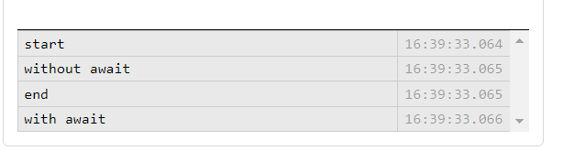

let a = 0

async function changeA() {

a = 20

await 0

a = 30

}

console.log('start', a)

changeA().then(() => console.log('after change', a))

console.log('end', a)

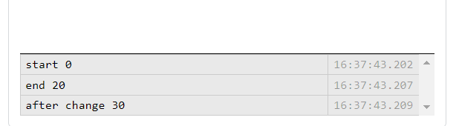

JavaScript code runs in one thread. No two lines of code run at the same time.

Asnychrouns code just stops executing when it encounters await and goes back to the next fragment when the thread is free

const results = []

async function f1() {

for (let i = 0; i < 10; i += 1) {

await results.push('f1')

await 0

}

}

async function f2() {

for (let i = 0; i < 10; i += 1) {

await results.push('f2')

}

}

f1()

f2()

setTimeout(() => {

console.log(results)

}, 100)

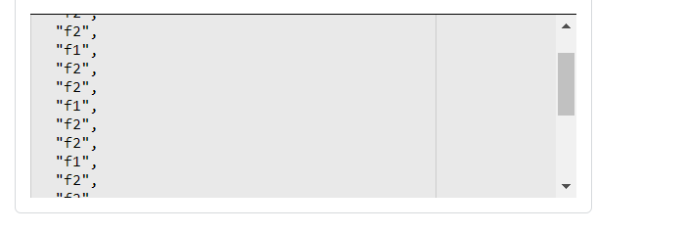

# 21 [usage of spread syntax code with map function](https://stackoverflow.com/questions/73965886/usage-of-spread-syntax-code-with-map-function)

I have some familiarity with the ... operator[spread syntax](https://developer.mozilla.org/en-US/docs/Web/JavaScript/Reference/Operators/Spread_syntax)

and recently I saw a developer use the spread syntax (as attached in snippet as ) [...document.querySelectorAll('#wrapper button')].map((button)=> button.addEventListener('click',Add));

the above **... spread syntax with the map function** looks tough for me to understand, can someone help me understand it in simple terms conceptually..thanks for your time

document.addEventListener('DOMContentLoaded', () => {

var temp = [];

var arrayOfStrings = [];

console.log(document.querySelectorAll('#wrapper button')) //choose button only in the wrapper div and not the others like CLR

//listen to only button events(other than the CLR)

document.querySelectorAll('#wrapper button').forEach(button => button.addEventListener('click', Calculat));

//listen to CLR button events

document.getElementById('clear1').addEventListener('click', () => {

temp = [];

arrayOfStrings = [];

document.querySelector('.my_flex').textContent = ('');

});

function Calculat(e) {

z = e.target.innerText;

// console.log(z);

document.querySelector('.my_flex').append(z); //append to the flex object

if (z == '=') {

document.querySelector('.my_flex').append(eval(arrayOfStrings));

return false;

}

temp.push(z);

arrayOfStrings = temp.join("");

}

});

div {

width: 7cm;

}

button {

border: 0;

line-height: 3.5;

padding: 0 20px;

font-size: 1rem;

text-align: center;

/*align the text f the button to the center*/

color: #fff;

text-shadow: 1px 1px 1px #000;

border-radius: 10px;

background-color: rgba(220, 0, 0, 1);

background-image: linear-gradient(to top left, rgba(0, 0, 0, .2), rgba(0, 0, 0, .2) 30%, rgba(0, 0, 0, 0));

box-shadow: inset 2px 2px 3px rgba(255, 255, 255, .6), inset -2px -2px 3px rgba(0, 0, 0, .6);

}

button:hover {

background-color: green;

}

button {

border: 0;

line-height: 3.5;

padding: 0 20px;

font-size: 1rem;

text-align: center;

color: #fff;

text-shadow: 1px 1px 1px #000;

border-radius: 10px;

background-color: rgba(220, 0, 0, 1);

background-image: linear-gradient(to top left, rgba(0, 0, 0, .2), rgba(0, 0, 0, .2) 30%, rgba(0, 0, 0, 0));

box-shadow: inset 2px 2px 3px rgba(255, 255, 255, .6), inset -2px -2px 3px rgba(0, 0, 0, .6);

}

button:hover {

background-color: green;

}

.my_flex {

display: flex;

background-color: tomato;

margin: 8px;

padding: 20px;

font-size: 30px;

}

<a>Calculations(Simple Mathematics only, example: 1+7,2*8 etc):--</a>

<div id="wrapper">

<button>1</button>

<button>2</button>

<button>3</button>

<button>4</button>

<br>

<button>5</button>

<button>6</button>

<button>7</button>

<button>8</button>

<button>9</button>

<button>+</button>

<button>-</button>

<button>*</button>

<button>0</button>

<button>(</button>

<button>)</button>

<button>/</button>

<button>=</button>

<button>.</button>

</div>

<div><button id="clear1">CLEAR</button></div>

<div class="my_flex">

<!--just to get nice output on flex canvas -->

</div>

Seems like [...document.querySelectorAll(...)] is for copying the iterable/"array-like" result from querySelectorAll to a proper Array so you can then use .map and such on it.

– [CollinD](https://stackoverflow.com/users/5298696/collind)

[Oct 5, 2022 at 20:20](https://stackoverflow.com/questions/73965886/usage-of-spread-syntax-code-with-map-function#comment130599854_73965886)

* 2

Not all browsers support forEach on NodeLists. Some require an actual array. [css-tricks.com/snippets/javascript/…](https://css-tricks.com/snippets/javascript/loop-queryselectorall-matches/)

– [James](https://stackoverflow.com/users/535480/james)

[Oct 5, 2022 at 20:20](https://stackoverflow.com/questions/73965886/usage-of-spread-syntax-code-with-map-function#comment130599874_73965886)

* 2

This is much easier to understand Array.from(document.querySelectorAll(selector)).map(...)

– [zer00ne](https://stackoverflow.com/users/2813224/zer00ne)

[Oct 5, 2022 at 20:25](https://stackoverflow.com/questions/73965886/usage-of-spread-syntax-code-with-map-function#comment130599961_73965886)

* is there a specification anyone can share that states that the nodelist(document.querySelectorAll('#wrapper button') makes an array ..by using the code: [...document.querySelectorAll('#wrapper button')]..

– [Michael36](https://stackoverflow.com/users/19129298/michael36)

[Oct 5, 2022 at 21:01](https://stackoverflow.com/questions/73965886/usage-of-spread-syntax-code-with-map-function#comment130600578_73965886)

* 1

@James All browsers that support iterating node lists (i.e. spread syntax) also do support the forEach method

– [Bergi](https://stackoverflow.com/users/1048572/bergi)

[Oct 5, 2022 at 21:14](https://stackoverflow.com/questions/73965886/usage-of-spread-syntax-code-with-map-function#comment130600774_73965886)

It's not just pointless to use the array spread syntax here, it's also [pointless (and indeed confusing) to use map](https://stackoverflow.com/a/50140181/1048572). This should rather use the [forEach method](https://developer.mozilla.org/en-US/docs/Web/API/NodeList/forEach):

document.querySelectorAll('#wrapper button').forEach(button => {

button.addEventListener('click', calculate);

});

or even better just a simple for loop:

for (const button of document.querySelectorAll('#wrapper button')) {

button.addEventListener('click', calculate);

}

Should I use array methods like map and filter, if I'm not going to return anything?

No, you should not.

Why? Is just good practice?

Yes. It is a good practice to use the appropriate iteration method for the type of iteration you are doing. There are numerous ways to iterate for a reason. Pick the appropriate mechanism.

What are downsides of a return-less array method?

Using .map() and .filter() without actually returning anything from the callback have the following downsides:**Your code is misleading.**

The point of .map() and .filter() is to iterate over the array and produce a new array. When a developer reads some code and sees .map() or .filter() being used, they expect that there should be a returned array. When they don't see it being done that way, they will be confused, will initially feel like they don't understand the code. If I were doing a code review on code like this, I would not approve of code like this.

 Instead, use an iteration method that does not produce an output array such as for/of, a regular for loop or .forEach().

Using .map() or .filter() without returning anything from the callback is, just as the linter says, "probably a programming mistake" because that is not how those functions are designed to be used and there are appropriate alternatives when you don't want a returned array.

So, if you're just trying to do an iteration without creating any resulting array, use for/of or .forEach() or some other iteration scheme that isn't specifically designed to create an output array that you don't want.

forEach: This iterates over a list and applies some operation with side effects to each list member (example: saving every list item to the database) and does not return anything.

map: This iterates over a list, transforms each member of that list, and returns another list of the same size with the transformed members (example: transforming list of strings to uppercase). It does not mutate the array on which it is called (although the callback function may do so).

References

https://developer.mozilla.org/en-US/docs/Web/JavaScript/Reference/Global_Objects/Array/forEach

https://developer.mozilla.org/en-US/docs/Web/JavaScript/Reference/Global_Objects/Array/maphttps://developer.mozilla.org/en-US/docs/Web/JavaScript/Reference/Global_Objects/Array/map

ESLint is correct - if you don't have a return statement in a map or filter callback then you are indeed most likely misusing it. They *rely* on the return value to function. Otherwise you are just looping over the array for no real reason. In that case, you should be using .forEach

https://css-tricks.com/snippets/javascript/loop-queryselectorall-matches/

for (const button of document.querySelectorAll('#wrapper button')) {

button.addEventListener('click', calculate);

}

[The docs](https://developer.mozilla.org/en-US/docs/Web/API/NodeList)- are silent on this (apart from mentioning that for … of works), but [the NodeList interface](https://dom.spec.whatwg.org/#interface-nodelist) in the spec is marked as [iterable](https://webidl.spec.whatwg.org/#idl-iterable), which [spread syntax](https://developer.mozilla.org/en-US/docs/Web/JavaScript/Reference/Operators/Spread_syntax) is making use of.

---------------------------------------

# 23 [Debugging vanilla javascript promises in 2022 [closed]](https://stackoverflow.com/questions/73940437/debugging-vanilla-javascript-promises-in-2022)

https://stackoverflow.com/questions/25827234/how-to-debug-javascript-promises

<https://stackoverflow.com/questions/47216353/chrome-debugger-promises-dont-resolve-while-paused>

debugger;

console.log('start')

async function withAwait() {

await 0;

console.log('with await')

return Promise.resolve(100);

}

withAwait()

console.log('end')

answer:

withAwait().then((val) => { console.log("withAwait() promise resolved", val)});

# 24 [Blinking cursor forever during tailwind install process](https://stackoverflow.com/questions/73846771/blinking-cursor-forever-during-tailwind-install-process)

I am unable to search on SO hence detailing it here, this can be a duplicate question.Refer the Step 4:'Start the Tailwind CLI build process' [TailwindInstallation](https://tailwindcss.com/docs/installation) the question is once I run the MSDOS command for CSS processing: npx tailwindcss -i input.css -o output.css --watch , the rebuilding and done is OK with no errors (refer attached command image) but after that my cursor keeps blinking forever, so I cant issue any more DOS commands so then I need to hit CTRL C (say couple of times) to get a message 'Terminate Batch Job(Y/N)' and I choose Y and then its normal command line prompt.This is an irritant.What am I doing wrong , please advise

That command ends with --watch, so the process will keep running monitoring changes to the files and constantly update the Tailwind css output.

The idea is to leave it running while you are working on the site. If you still need the terminal for something else then open another terminal.

# 25 [Error while executing javascript promises](https://stackoverflow.com/questions/73924489/error-while-executing-javascript-promises)

I am getting console error as:**Uncaught (in promise) TypeError: Failed to execute 'createObjectURL' on 'URL': Overload resolution failed.**

I wish to know where I am going wrong in my concepts..Thanks

const myImage = document.querySelector("img");

const myRequest = new Request('elephant.jpg');

// console.log(myRequest)

fetch(myRequest)

.then((response) => {

if (!response.ok) {

throw new Error(`HTTP error! Status: ${response.status}`)

}

else {

console.log(`no HTTP error, elephant.jpg file is present,Status: ${response.status}`)

myBlob=response.blob();

const objectURL = URL.createObjectURL(myBlob);

myImage.src = URL.createObjectURL(response)

}

})

<h1>Fetch Request example</h1>

<img src="" />

const myImage = document.querySelector("img");

const myRequest = new Request('elephant.jpg');

// console.log(myRequest)

fetch(myRequest)

.then((response) => {

if (!response.ok) {

throw new Error(`HTTP error! Status: ${response.status}`)

}

else {

console.log(`no HTTP error, elephant.jpg file is present,Status: ${response.status}`)

myBlob=response.blob();

const objectURL = URL.createObjectURL(myBlob);

myImage.src = URL.createObjectURL(response)

}

})

<h1>Fetch Request example</h1>

<img src="" />

const myImage = document.querySelector("img");

const myRequest = new Request("elephant.jpeg");

fetch(myRequest).then(async (response) => {

if (!response.ok) {

throw new Error(`HTTP error! Status: ${response.status}`);

} else {

console.log(

`no HTTP error, elephant.jpg file is present,Status: ${response.status}`

);

myBlob = await response.blob() // ensure this is defined in your file

const objectURL = window.URL.createObjectURL(myBlob);

myImage.src = window.URL.createObjectURL(myBlob);

}

});

# 26 [How to confirm for JavaScript asynchronous calls? [closed]](https://stackoverflow.com/questions/73899801/how-to-confirm-for-javascript-asynchronous-calls)

document.addEventListener('DOMContentLoaded', () => {

flexStuff();

async function flexStuff() {

let tr = '{"https://create-react-app.dev/docs/getting-started":"React Start",\

"https://developer.mozilla.org/en-US/docs/Web/Guide/AJAX":"ajax",\

"https://developer.mozilla.org/en-US/docs/Web/CSS/inheritance#inherited_properties":"CSS",\

"https://developer.mozilla.org/en-US/docs/Learn/JavaScript/Building_blocks/Events#using_addeventlistener":"event listeners"\

}';

const obj121 = JSON.parse(tr);

for (let key in obj121) {

d1 = document.createElement('div');

d1.setAttribute('id', obj121[key]);

d1.innerHTML = `<a href=${key}>${obj121[key]}</a>`;

document.querySelector('.my_flexx').appendChild(d1);

}

await 2022;

}

});

an async function without an await expression will run synchronously. If there is an await expression inside the function body, however, the async function will always complete asynchronously.

Yes, everything in the async function will run synchronously until await is encountered.

variant 1

async function withoutAwait() {

console.log('without await')

}

async function withAwait() {

await 0

console.log('with await')

}

console.log('start')

withoutAwait()

withAwait()

console.log('end')

variant 2

let a = 0

async function changeA() {

a = 20

await 0

a = 30

}

console.log('start', a)

changeA().then(() => console.log('after change', a))

console.log('end', a

variant 3

const results = []

async function f1() {

for (let i = 0; i < 10; i += 1) {

await results.push('f1')

await 0

}

}

async function f2() {

for (let i = 0; i < 10; i += 1) {

await results.push('f2')

}

}

f1()

f2()

setTimeout(() => {

console.log(results)

}, 100)

# 27 [Clicking on an empty area causes events to be generated](https://stackoverflow.com/questions/73758131/clicking-on-an-empty-area-causes-events-to-be-generated)

I am currently implementing a calculator using HTML,CSS,Javascript.Chrome v 105 used,javascript event bubbling has been used.The calculator works ok if I click on the buttons but the problem occurs if I click a little bit right on an empty area(about say 1 or 2 cm in the empty area to the right of the numbers 2 or 8 or 0 or the . symbol) then I see multiple events being generated(in the console.log and UI) and the corresponding button values in the div being captured so how do I rectify this issue, please help me understand as I am not so experienced in javascript.

That's because you set the listener to the wrapper div. set the listener only to every button who is a child of #wrapper:

works but please explain the ... dots and the [] operators you have used in : [...document.querySelectorAll('#wrapper button')].map((button)=> button.addEventListener('click',Calculat));

– [John Ray](https://stackoverflow.com/users/20021858/john-ray)

* @JohnRay they used to convert list the into array, changed to forEach .. //listen to only button events(other than the CLR)

document.querySelectorAll('#wrapper button').forEach(button=> button.addEventListener('click',Calculat));

What is the difference between class and classname in javascript?

Answer 1:

Class is an attribute in an html element <span class='classy'></span>

While, on the other hand, .className is a property that can by called on an element to get/set its class.

var element = document.createElement('span');

element.className = 'classy'

// element is <span class='classy'></span>

Setting the class can also be accomplished with .getAttribute('class') and .setAttribute('class', 'classy'). We change manipulate classes so often, however, that it merited its own .className method.

# 28 [Unable to render react](https://stackoverflow.com/questions/73514308/unable-to-render-react)

<script>

const root = ReactDOM.createRoot(document.getElementById('root'));

root.render(<h1>Hello, world!</h1>);

</script>

<div id="root">

</div>

I am running the html snippet but getting a console error message , this code is from <https://reactjs.org/docs/hello-world.html> ,it runs fine on codepen but not my local browser, please help as i am new to react.js

That snippet won't run in your browser's console as-is. In the code pen go to settings > JS > Add External Scripts/Pens. You'll see react and react-dom are dependencies for the code to run.

This tutorial for create-react-app will help you get everything installed correctly so you can try the hello world example - <https://create-react-app.dev/docs/getting-started/>

Aswer2:

Here's the full setup in order for this example code to run:

<!-- INCLUDE REACT LIB -->

<script src="https://unpkg.com/react@18/umd/react.production.min.js" crossorigin></script>

<!-- INCLUDE REACTDOM LIB -->

<script src="https://unpkg.com/react-dom@18/umd/react-dom.production.min.js" crossorigin></script>

<!-- INCLUDE BABEL COMPILER LIB FOR JSX -->

<script src="https://unpkg.com/babel-standalone@6/babel.min.js"></script>

<div id="root"></div>

<!-- Change the type to text/babel in order for the Babel compiler to detect and compile the JSX syntax -->

<script type="text/babel">

const root = ReactDOM.createRoot(document.getElementById('root'));

root.render(<h1>Hello, world!</h1>);

</script>

You can find the CDN links used in this example for the React, ReactDOM and Babel libraries on the [link](https://create-react-app.dev/docs/getting-started/) that @abo mentioned above.

Happy Hacking and welcome to the wonderful world of React! ;)

----------------------------------------------------------------

# 29 [Image not loading in html page](https://stackoverflow.com/questions/73268366/image-not-loading-in-html-page)

<https://jsfiddle.net/jonathan668/vwc1hd8z/6/>

I am trying to flip images whenever user clicks the next button on the web page

Refer https://jsfiddle.net/jonathan668/vwc1hd8z/6/

Issue is My image urls generated via javascript are not loading to html

You don't need to create a new Image object to change the source. Remove line 8 of your JavaScript image5 = new Image(); and it should work perfectly.

# 30 [I need help to overwrite images on html page upon clicking a button [closed]](https://stackoverflow.com/questions/73303209/i-need-help-to-overwrite-images-on-html-page-upon-clicking-a-button)

I have stored my images in an array called arr I have put a button on the html page called 'Next' so that whenever the user clicks the next button,the next image is picked up and overwrites the previous one the issue is the image on html page does not get overwritten by the next image( stored in the array),so how do I accomplish this

please help me as I am new to javascipt.

<body>

<script>

var arr = ["apple.jpg","kiwi.jpg", "pineapple.jpg","mango.jpg"];

function a()

{

image5 = document.getElementById("image5");

console.log(arr[0]);

image5=new Image();

image5.src = arr[0];

console.log("file is " + image5.src);

arr.splice(0,1);

}

</script>

<img src="apple.jpg" id="image5" style="width:300px;height:300px;">

<button onClick="a();">Next</button>

</body>

Ans1:

Why did you add this line: image5=new Image(); ? You want to change what #image5 shows, but you then overwrite the reference to that element (stored in image5) with something new (new Image()) and change the .src property of that new object.

– [Andreas](https://stackoverflow.com/users/402037/andreas)

[Aug 10 at 8:40](https://stackoverflow.com/questions/73303209/i-need-help-to-overwrite-images-on-html-page-upon-clicking-a-button#comment129455284_73303209)

* Sorry my typo ; now i removed it. i can see the file path being created in console log but image on html page is not getting overwritten.pls help me

– [jonathan](https://stackoverflow.com/users/19542576/jonathan)

[Aug 10 at 8:44](https://stackoverflow.com/questions/73303209/i-need-help-to-overwrite-images-on-html-page-upon-clicking-a-button#comment129455377_73303209)

* Just remove the line with that new Image() call

– [Andreas](https://stackoverflow.com/users/402037/andreas)

[Aug 10 at 8:46](https://stackoverflow.com/questions/73303209/i-need-help-to-overwrite-images-on-html-page-upon-clicking-a-button#comment129455414_73303209)

* Andreas Thanks a lot for your help..works now

– [jonathan](https://stackoverflow.com/users/19542576/jonathan)

[Aug 10 at 8:48](https://stackoverflow.com/questions/73303209/i-need-help-to-overwrite-images-on-html-page-upon-clicking-a-button#comment129455456_73303209)

Ans2:

I pretty much just cleaned up the code and had a variable that is the indicator to which picture comes up on the array and its loops. Also, I made the script tag defer so the tag loads after the whole page is so the function runs

<body>

<script defer>

var arr = ["apple.jpg","kiwi.jpg", "pineapple.jpg","mango.jpg"];

var image5 = document.getElementById("image5");

var i = 0;

function a(){

if(i>=4){i=0;}

image5.src = arr[i];

console.log("file is " + image5.src);

i++;

}

</script>

<img src="apple.jpg" id="image5" style="width:300px;height:300px;">

<button onclick="a()">Next</button>

</body>

# 31 [Can I remove the duplicacy of javascript eventlisteners(each of the listeners listens to either a mathematical operator or a variable between 0 and 9](https://stackoverflow.com/questions/73520976/can-i-remove-the-duplicacy-of-javascript-eventlistenerseach-of-the-listeners-li)

let buffer = [];

let arrayOfNumbers=[];

document.addEventListener('DOMContentLoaded', () => {

document.getElementById('buffer1').style.color = 'purple';

document.getElementById('buffer1').style.backgroundColor = 'tomato';

document.getElementById('buffer1').style.fontWeight = 'bold';

document.getElementById('one').addEventListener('click', () => {

Calculat(document.getElementById('one').textContent);});

document.getElementById('two').addEventListener('click', () => {

Calculat(document.getElementById('two').textContent);});

document.getElementById('three').addEventListener('click', () => {

Calculat(document.getElementById('three').textContent);});

document.getElementById('four').addEventListener('click', () => {

Calculat(document.getElementById('four').textContent);});

document.getElementById('five').addEventListener('click', () => {

Calculat(document.getElementById('five').textContent);});

document.getElementById('six').addEventListener('click', () => {

Calculat(document.getElementById('six').textContent);});

document.getElementById('seven').addEventListener('click', () => {

Calculat(document.getElementById('seven').textContent);});

document.getElementById('eight').addEventListener('click', () => {

Calculat(document.getElementById('eight').textContent);});

document.getElementById('nine').addEventListener('click', () => {

Calculat(document.getElementById('nine').textContent);});

document.getElementById('zero').addEventListener('click', () => {

Calculat(document.getElementById('zero').textContent);});

document.getElementById('dot').addEventListener('click', () => {

Calculat(document.getElementById('dot').textContent);});

//operators

document.getElementById('plus').addEventListener('click', () => {

Calculat(document.getElementById('plus').textContent);});

document.getElementById('sub').addEventListener('click', () => {

Calculat(document.getElementById('sub').textContent);});

document.getElementById('multiply').addEventListener('click', () => {

Calculat(document.getElementById('multiply').textContent);});

document.getElementById('divide').addEventListener('click', () => {

Calculat(document.getElementById('divide').textContent);});

document.getElementById('lbrace').addEventListener('click', () => {

Calculat(document.getElementById('lbrace').textContent);});

document.getElementById('rbrace').addEventListener('click', () => {

Calculat(document.getElementById('rbrace').textContent);});

document.getElementById('equal').addEventListener('click', () => {

Calculat(document.getElementById('equal').textContent);});

document.getElementById('clear').addEventListener('click', () => {

buffer = [];

arrayOfNumbers=[];

document.getElementById('result').textContent=('');

document.getElementById('buffer1').textContent=('');

});

});

function Calculat(z) {

document.getElementById('buffer1').append(z);

if (z =='='){

console.log("Mathematical Array : " + arrayOfStrings);

console.log("Result is : " + eval(arrayOfStrings));

document.getElementById('result').style.color = 'red';

document.getElementById('result').style.backgroundColor = 'lightgrey';

document.getElementById('result').style.fontWeight = 'bold';

let result = Function("return " + arrayOfStrings)();

console.log(result)

document.getElementById('result').textContent=result;

return false;

}

buffer.push(z);

arrayOfStrings = buffer.join("");

}

.flex-container {

display: flex;

background-color: Blue;

justify-content: left;

}

.flex-container > div {

background-color: deepskyblue;

margin: 8px;

padding: 20px;

font-size: 30px;

}

<div class="flex-container">

<div>Array:</div>

<div id="buffer1">&nbsp;&nbsp;&nbsp;&nbsp;</div>

</div>

<div class="flex-container">

<div id="one">1</div>

<div id="two">2</div>

<div id="three">3</div>

<div id="four">4</div>

<div id="zero">0</div>

</div>

<div class="flex-container">

<div id="five">5</div>

<div id="six">6</div>

<div id="seven">7</div>

<div id="eight">8</div>

<div id="nine">9</div>

</div>

<div class="flex-container">

<div id="plus">+</div>

<div id="sub">-</div>

<div id="multiply">*</div>

<div id="divide">/</div>

<div id="equal">=</div>

</div>

<div class="flex-container">

<div id="dot">.</div>

<div id="clear">CLR</div>

<div id="lbrace">(</div>

<div id="rbrace">)</div>

</div>

<div class="flex-container">

<div>Result:</div>

<div id="result"></div>

</div>

Run code snippetHide resultsExpand snippet

I have made a working Javascript calculator for basic mathematics operations,It take in a integer or float and performs the mathematical evaluation;I feel some functions in the javascript like Calculat are duplicated. Please suggest some code optimisation ideas (for example for action event listeners or any other code)

1

you can use [bubbling](https://javascript.info/bubbling-and-capturing) here, add some div wrapper to html like

<div id="wrapper">

<!-- current html -->

</div>

then attach event listener to it and remove all listeners that is inside your wrapper

document.getElementById('wrapper').addEventListener('click', (e) => Calculat(e.target.textContent))

document.addEventListener('DOMContentLoaded', () => {

document.getElementById('buffer1').style.color = 'purple';

document.getElementById('buffer1').style.backgroundColor = 'tomato';

document.getElementById('buffer1').style.fontWeight = 'bold';

document.getElementById('wrapper').addEventListener('click', (e) => Calculat(e.target.textContent))

document.getElementById('clear').addEventListener('click', () => {

buffer = [];

arrayOfNumbers=[];

document.getElementById('result').textContent=('');

document.getElementById('buffer1').textContent=('');

});

});

# 31 [using a div class doesnt render html page](https://stackoverflow.com/questions/73592932/using-a-div-class-doesnt-render-html-page)

let x=[];

const json1 = '{"https://www.w3schools.com":"w3schools"}';

const obj1 = JSON.parse(json1);

ol = document.createElement('ol');

ser.appendChild(ol);

for (var key in obj1){

x= document.createElement('li');

x.innerHTML="<a href=" + key + ">" + obj1[key]+"</a>";

ol.appendChild(x);

}

.ser{

color: red;

}

<div class="ser">welcome</div>

Due to an IE quirk, adding an id to an element makes it exist for your JS code to reference directly. This was kept for legacy reasons but in theory you would have to declare the variable first, using for instance const ser = document.getElementById('ser');. This doesn't work with classes because the whole point of classes is to apply them to multiple elements.

Answer1:

tried and it worked both ways : document.getElementById('ser').appendChild(ol); document.querySelector('.ser').appendChild(ol);

this worked too; so got conceptually your 3rd variant meaning ...( and as per MDN we can use the query selector to query by ID also, which by the way I never implemented before )..details: <style>#ser{color: cyan;}</style> <body> <div id="ser">welcome</div> <script> let x=[]; const json1 = '{"google.com":"google"}'; const obj1 = JSON.parse(json1); ol = document.createElement('ol'); document.querySelector('#ser').appendChild(ol); for (var key in obj1){ x= document.createElement('li'); x.innerHTML="<a href=" + key + ">" + obj1[key]+"</a>"; ol.appendChild(x);}

– [jonathan](https://stackoverflow.com/users/19542576/jonathan)

-----------------------------------------------------------------

# 32 [My generated link in the unordered list is not navigable](https://stackoverflow.com/questions/73583672/my-generated-link-in-the-unordered-list-is-not-navigable)

let x=[];

let array = []

const json1 = '{"https://www.w3schools.com/html/":"check w3 schools"}';

const obj1 = JSON.parse(json1);

array=Object.getOwnPropertyNames(obj1);

ul = document.createElement('ul');

ser.appendChild(ul);

x= document.createElement('li');

x.innerText="<a href=\"" + array[0]+ "\">"+"</a>";//hyper link not clickable

ul.appendChild(x);

<div id="ser"></div>

 Run code snippet

the javascript code renders the unordered list but the link in the list() is not navigable.Please advice on solving this issue.

innerText sets *text*. Use innerHTML instead.

– [Cerbrus](https://stackoverflow.com/users/1835379/cerbrus)

[Sep 2 at 13:56](https://stackoverflow.com/questions/73583672/my-generated-link-in-the-unordered-list-is-not-navigable#comment129940798_73583672)

* used innerHTML , and the link in the unordered list completely disappears..

– [jonathan](https://stackoverflow.com/users/19542576/jonathan)

[Sep 2 at 13:59](https://stackoverflow.com/questions/73583672/my-generated-link-in-the-unordered-list-is-not-navigable#comment129940870_73583672)

* 1

You also need to add some text inside the tag - <a href="...">link text here</a>

– [phuzi](https://stackoverflow.com/users/592958/phuzi)

[Sep 2 at 14:01](https://stackoverflow.com/questions/73583672/my-generated-link-in-the-unordered-list-is-not-navigable#comment129940942_73583672)

* 1

Because there's no text in the `<a></a> tag.

– [Cerbrus](https://stackoverflow.com/users/1835379/cerbrus)

[Sep 2 at 14:01](https://stackoverflow.com/questions/73583672/my-generated-link-in-the-unordered-list-is-not-navigable#comment129940947_73583672)

* i put console.log(x); before the /script tag and the <a></a> tag in the console is :<a href="[w3schools.com/html/"></a](https://www.w3schools.com/html/%22%3E%3C/a)>

– [jonathan](https://stackoverflow.com/users/19542576/jonathan)

[Sep 2 at 14:09](https://stackoverflow.com/questions/73583672/my-generated-link-in-the-unordered-list-is-not-navigable#comment129941128_73583672)   Delete

But there's no text inside the a tag to be rendered as the link. You would need <a href="w3schools.com/html/">W3Schools</a> to have the link show up and be rendered as "W3Schools"

– [phuzi](https://stackoverflow.com/users/592958/phuzi)

[Sep 2 at 14:11](https://stackoverflow.com/questions/73583672/my-generated-link-in-the-unordered-list-is-not-navigable#comment129941184_73583672)

* so Thanks this solved it x.innerHTML="<a href=\"" + array[0]+ "\">w3schools"+"</a>";

– [jonathan](https://stackoverflow.com/users/19542576/jonathan)

[Sep 2 at 14:12](https://stackoverflow.com/questions/73583672/my-generated-link-in-the-unordered-list-is-not-navigable#comment129941200_73583672)    Delete

Answer2:

There are multiple fixes so take a look at this

let array = []

const json1 = '{"https://www.w3schools.com/html/":"check w3 schools"}';

const obj1 = JSON.parse(json1);

array = Object.getOwnPropertyNames(obj1);

const ul = document.querySelector('#ser').appendChild(document.createElement('ul'));

const x = document.createElement('li');

const a = document.createElement('a');

a.setAttribute("href", array[0]);

a.innerHTML = array[0];

x.appendChild(a);

# 33 [Not being able to use empty wrapper <> in reactJS](https://stackoverflow.com/questions/75307755/not-being-able-to-use-empty-wrapper-in-reactjs)

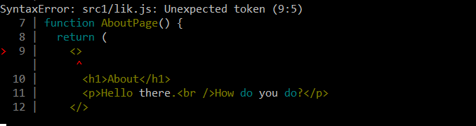

as suggested in [aboutfunction](https://beta.reactjs.org/learn#writing-markup-with-jsx) I tried using an empty wrapper <>...</> wrapper but error is being thrown as Unexpected token for <> ..please help in error resolution

const rootx = ReactDOM.createRoot(document.getElementById('Abt'));

const element5 = <AboutPage />;

rootx.render(element5);

function AboutPage() {

return (

<>

<h1>About</h1>

<p>Hello there.<br />How do you do?</p>

</>

);

}

<!DOCTYPE html>

<html>

<head>

<meta charset="UTF-8" />

<title>Add React in One Minute</title>

</head>

<body>

<h2>Add React in One Minute</h2>

<!-- We will put our React component inside this div. -->

<link rel="icon" type="./x-icon" href="./favicon.ico">

<div id="Abt"></div>

<!-- Load React. -->

<!-- Note: when deploying, replace "development.js" with "production.min.js". -->

<script src="https://unpkg.com/react@18/umd/react.development.js" crossorigin></script>

<script src="https://unpkg.com/react-dom@18/umd/react-dom.development.js" crossorigin></script>

<!-- Load your React component. -->

<script type="module" src="lik.js"></script>

</body>

</html>

new version of babel can be updated via step 2 of [babel version update](https://beta.reactjs.org/learn/add-react-to-a-website#add-jsx-to-a-project)

npm install @babel/cli@7 babel-preset-react-app@10

and updated new JSX preprocessor command :

npx babel --watch src --out-dir . --presets babel-preset-react-app/prod

this will allow the empty<>..</> to compile and render (attached screenshot)

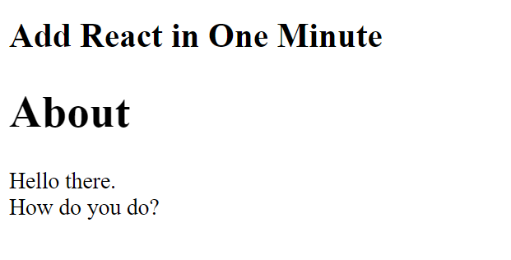

# 34 [Getting error while using import { useState } from 'react';](https://stackoverflow.com/questions/75337620/getting-error-while-using-import-usestate-from-react)

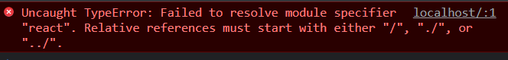

import { useState } from 'react';

const root10 = ReactDOM.createRoot(document.getElementById('Xy'));

const element10 = <Pile />;

root10.render(element10);

function Pile() {

return (

<img

src="https://i.imgur.com/QIrZWGIs.jpg"

alt="Alan L. Hart"

/>

);

}

<!DOCTYPE html>

<html>

<head>

<meta charset="UTF-8" />

<title>Test Page-React</title>

</head>

<body>

<link rel="icon" type="./x-icon" href="./favicon.ico">

<h3>https://beta.reactjs.org/learn/describing-the-ui</h3>

<h4>https://transform.tools/html-to-jsx</h4>

<h5>https://developer.mozilla.org/en-US/docs/Web/JavaScript/Guide/Modules</h5>

<div id="Xy"></div>

<!-- Load React. -->

<!-- Note: if deploying, replace "development.js" with "production.min.js". -->

<script src="https://unpkg.com/react@18/umd/react.development.js" crossorigin></script>

<script src="https://unpkg.com/react-dom@18/umd/react-dom.development.js" crossorigin></script>

<!-- Load your React component. -->

<script type="module" src="test.js"></script>

</body>

</html>

# 35 [css SYNTAX is not displaying list [closed]](https://stackoverflow.com/questions/73212430/css-syntax-is-not-displaying-list)

.thirdrow ul {

list-style-position: inside;

font-size: 120%;

bottom: 0;

right: 0;

margin-top: 0.3cm;

padding-top: 0.6cm;

}

<div id="thirdrow">

<ul>

<li>...</li>

<li>...</li>

</ul>

</div>

Just change the selector to - **#thirdrow ul** and that should work.

36 is there a way to flip only the flipcard and not the text containing in the flipcard

0

The problem I have is whenever I flip the card(by hovering on the card) the text containing in the flipcard(Yellow or Red) depending on the flipcard you hover gets mirrored, how should I code to avoid text mirroring? I am new , please help as I am new to HTML concepts

img {

width:200px;

height:200px;

}

.flip-card {

display:inline-block;

width: 200px;

height: 200px;

border: 5px solid #555;

perspective: 1000px; /* Remove this if you don't want the 3D effect */

}

/* This container is needed to position the front and back side */

.flip-card-inner {

position: absolute:

width: 100%;

height: 100%;

text-align: center;

transition: transform 0.8s;

transform-style: preserve-3d;

}

/* Do an horizontal flip when you move the mouse over the flip box container */

.flip-card:hover .flip-card-inner {

transform: rotateY(180deg);

}

.centrd {

position: absolute;

top: 50%;

left: 50%;

transform: translate(-50%, -50%);

font-weight: bold;

}

/* Position the front and back side */

.flip-card-front, .flip-card-back {

position: absolute;

width: 100%;

height: 100%;

backface-visibility: hidden;

}

/* Style the back side */

.flip-card-back {

background-color: lightgrey;

color: red;

transform: rotateY(180deg);

}

<div class="flip-card">

<div class="flip-card-inner"><div class="centrd">Yellow</div><img src="yellow.png">

</div>

</div>

 have an idea, let's rotate the text in reverse to the card. Wonder if it'll work. Caveat: You will have to center the centrd element without transform because you can't have 2 transforms.

Edit: however when combined with image the effect is a little different. Might as well position absolute the centrd word which is a more natural solution to keep the word out of the flow of the card.

img {

width: 200px;

height: 200px;

}

.flip-card {

display: inline-block;

width: 200px;

height: 200px;

border: 5px solid #555;

perspective: 1000px;

/* Remove this if you don't want the 3D effect */

}

/* This container is needed to position the front and back side */

.flip-card-inner {

position: absolute: width: 100%;

height: 100%;

text-align: center;

transition: transform 0.8s;

transform-style: preserve-3d;

}

/* Do an horizontal flip when you move the mouse over the flip box container */

.flip-card:hover .flip-card-inner {

transform: rotateY(180deg);

}

.flip-card:hover .centrd {

transform: rotateY(-180deg);

}

.flip-card .centrd {

transition: transform 0.8s;

transform-style: preserve-3d;

}

.centrd {

position: absolute;

width: 100%;

top: 50%;

text-align: center;

font-weight: bold;

}

/* Position the front and back side */

.flip-card-front,

.flip-card-back {

position: absolute;

width: 100%;

height: 100%;

backface-visibility: hidden;

}

/* Style the back side */

.flip-card-back {

background-color: lightgrey;

color: red;

transform: rotateY(180deg);

}

<div class="flip-card">

<div class="flip-card-inner">

<div class="centrd">Yellow</div><img src="yellow.png">

</div>

</div>

idea is unique and good

– [Michael36](https://stackoverflow.com/users/19129298/michael36)

[Aug 12, 2022 at 6:27](https://stackoverflow.com/questions/73326555/is-there-a-way-to-flip-only-the-flipcard-and-not-the-text-containing-in-the-flip#comment129500867_73326815)

* 1

Did you replace all the .centrd in the css? there are a few. I would need to see an example if that doesn't work.

– [IT goldman](https://stackoverflow.com/users/3807365/it-goldman)

[Aug 13, 2022 at 17:09](https://stackoverflow.com/questions/73326555/is-there-a-way-to-flip-only-the-flipcard-and-not-the-text-containing-in-the-flip#comment129528989_73326815)

* 1

What about .flip-card .centrd? by your logic it should be .flip-card #centrd

– [IT goldman](https://stackoverflow.com/users/3807365/it-goldman)

[Aug 13, 2022 at 17:21](https://stackoverflow.com/questions/73326555/is-there-a-way-to-flip-only-the-flipcard-and-not-the-text-containing-in-the-flip#comment129529135_73326815)

* got your point sorry i will try and come back

– [Michael36](https://stackoverflow.com/users/19129298/michael36)

[Aug 13, 2022 at 17:24](https://stackoverflow.com/questions/73326555/is-there-a-way-to-flip-only-the-flipcard-and-not-the-text-containing-in-the-flip#comment129529176_73326815)

* it works. ( you were right ,I hadnt replaced everywhere) so now both the .centrd and #centrd works

– [Michael36](https://stackoverflow.com/users/19129298/michael36)

[Aug 13, 2022 at 17:47](https://stackoverflow.com/questions/73326555/is-there-a-way-to-flip-only-the-flipcard-and-not-the-text-containing-in-the-flip#comment129529498_73326815)

MISCELLANEOUS

Changing width of DIV element is a WORTH IT!! :

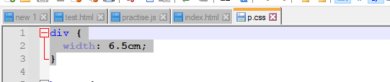

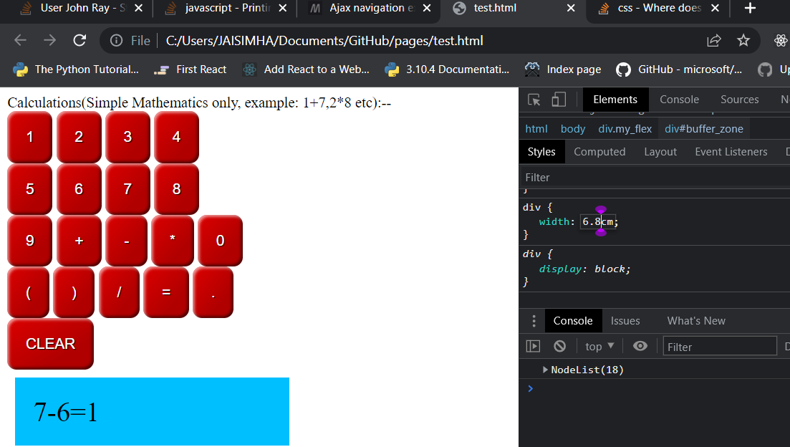

Next don’t set DIV width(this will occupy the whole window):

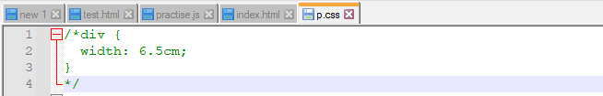

Difference between visibility and display:  
<!--there u go:- To have an element take up the space that it would normally take, but without actually rendering anything, use the visibility property instead.  
  
display:block

The element generates a block element box, generating line breaks both before and after the element when in the normal flow.

Display:inline

The element generates one or more inline element boxes that do not generate line breaks before or after themselves. In normal flow, the next element will be on the same line if there is space

display:none

Turns off the display of an element so that it has no effect on layout (the document is rendered as though the element did not exist). All descendant elements also have their display turned off.

<body>

<a class="a">a</a>

<a class="b">b</a>

<a class="c">c</a>

<style>

Makes the b element disappear so adds 2 space between a and c

.b{display:inline;visibility:hidden;}

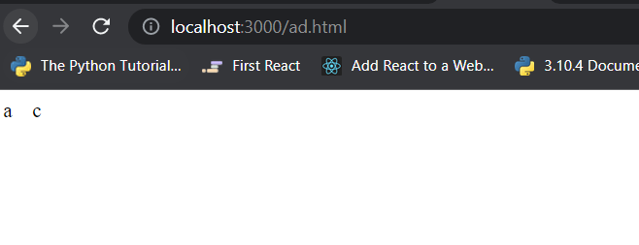

Makes the b element GO OFF so adds 1 space between a and c

.b{display:none;visibility:hidden or visibility:visible;}

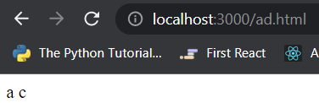

</style></body>

CSS thinks in parent child way:

<aside>

<p>The Rough-skinned Newt defends itself with a deadly neurotoxin.</p>

</aside>

So,

ASIDE IS PARENT

P IS CHILD

> CSS Selector

1st variant

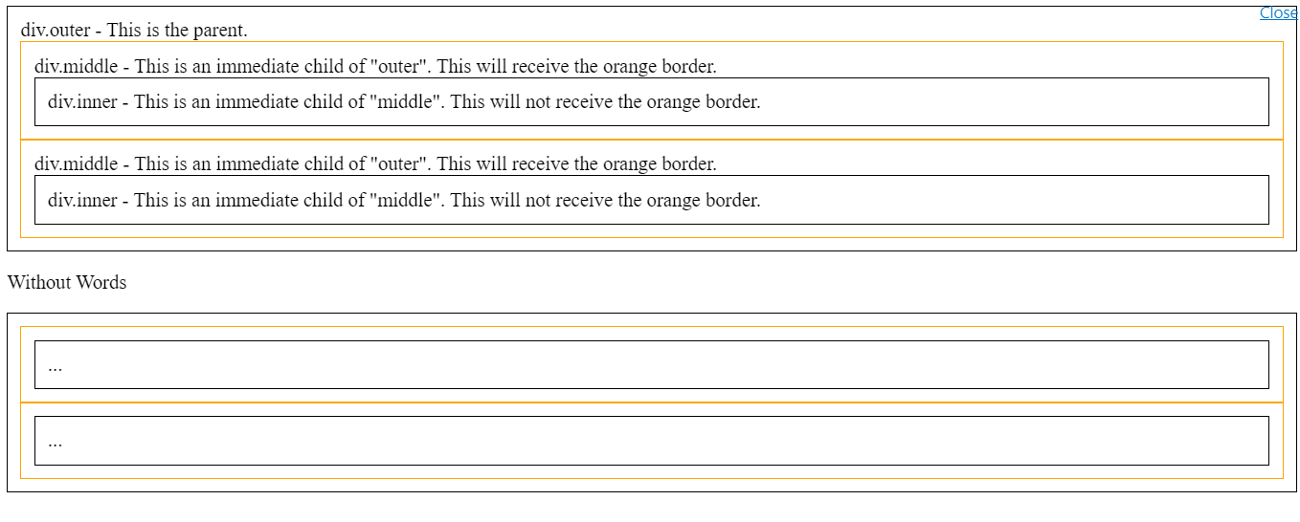

.css file

div {

border: 1px solid black;

padding: 10px;

}

.outer > div {

border: 1px solid orange;

}

.html file

<div class='outer'>

div.outer - This is the parent.

<div class="middle">

div.middle - This is an immediate child of "outer". This will receive the orange border.

<div class="inner">div.inner - This is an immediate child of "middle". This will not receive the orange border.</div>

</div>

<div class="middle">

div.middle - This is an immediate child of "outer". This will receive the orange border.

<div class="inner">div.inner - This is an immediate child of "middle". This will not receive the orange border.</div>

</div>

</div>

<p>Without Words</p>

<div class='outer'>

<div class="middle">

<div class="inner">...</div>

</div>

<div class="middle">

<div class="inner">...</div>

</div>

</div>

2nd variant

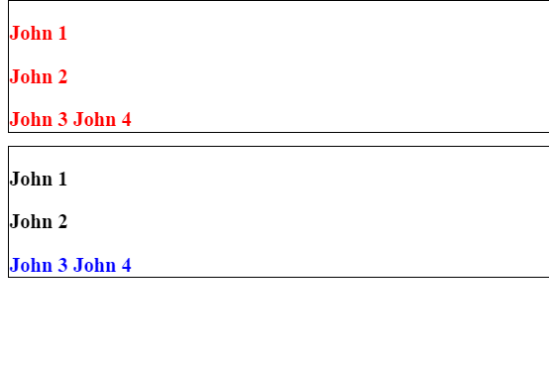

.css file

div { border: 1px solid black; margin-bottom: 10px; }

.a b { color: red; } /* every John is red */

.b > b { color: blue; } /* Only John 3 and John 4 are blue */

.html file Parent is <div class="a">

Child is <p>

Grandchild is <b>

<div class="a">

<p><b>John 1</b></p>

<p><b>John 2</b></p>

<b>John 3</b>

<b>John 4</b>

</div>

Next….

Parent is <div class="b">

Child is <b>

<div class="b">

<p><b>John 1</b></p>

<p><b>John 2</b></p>

<b>John 3</b>

<b>John 4</b>

</div>

[innerhtml throws error while displaying html link](https://stackoverflow.com/questions/73783279/innerhtml-throws-error-while-displaying-html-link):

<https://stackoverflow.com/questions/10055773/double-quote-in-javascript-string>

function toggleNav1()

{

//this below statement executes

document.getElementById('mobile').innerHTML="www.cnn.com"

//but this below statement is an error:

document.getElementById('mobile').innerHTML="<a href="https://www.google.com">google</a>"

}

So Use:

document.getElementById('mobile').innerHTML="<a href=\"https://www.google.com\">google</a>"

document.getElementById('mobile').innerHTML='<a href="https://www.google.com">abcle</a>'

Try to use sections instead of div for HTML line breakups(example):

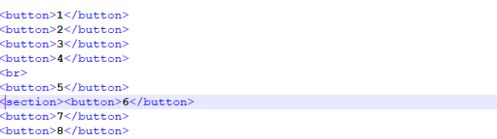

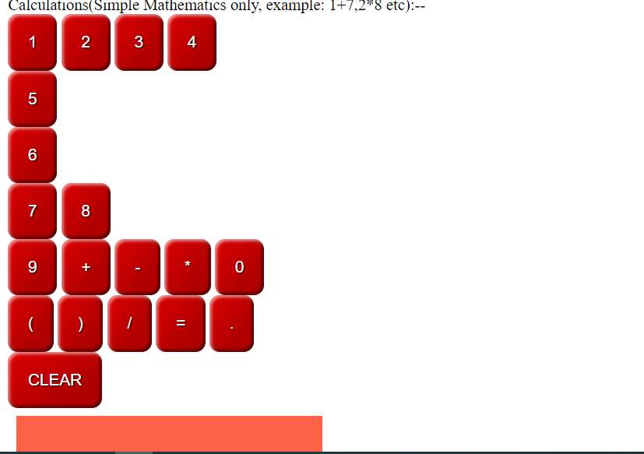

Never use document.write instead use textContent:

// first create an array

let resultsArray = [];

// fill the array with numbers 0 - 199

for (let i=0; i < 200; i += 1) {

resultsArray.push(i);

}

// print it to pre#log

document.querySelector("#log").textContent = resultsArray.join(" ");

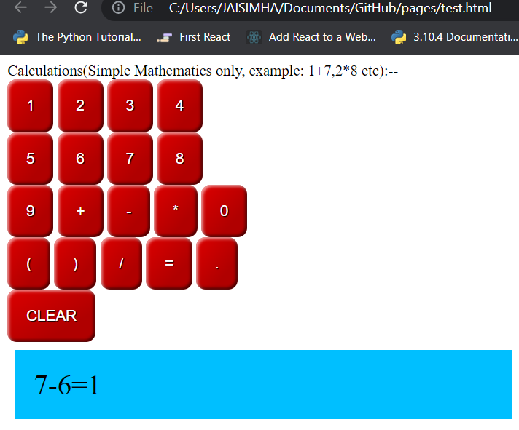

Next using chrome developer tools try changing the values(make div width to 0 and you can get it confirmed by seeing the strikethrough line:

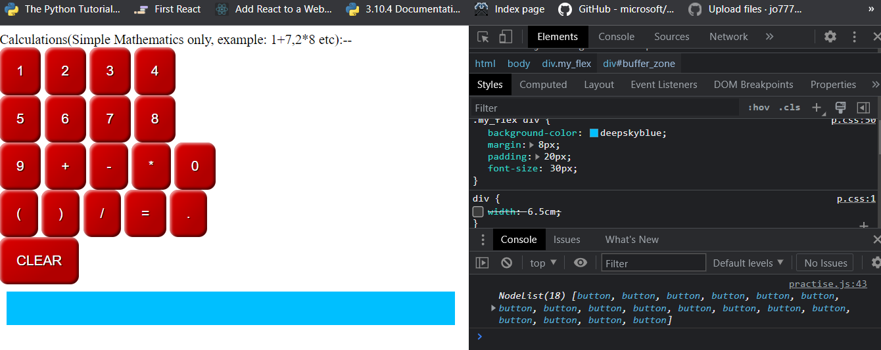

Now change it to say 4 cm and observe elements are getting wrapped:

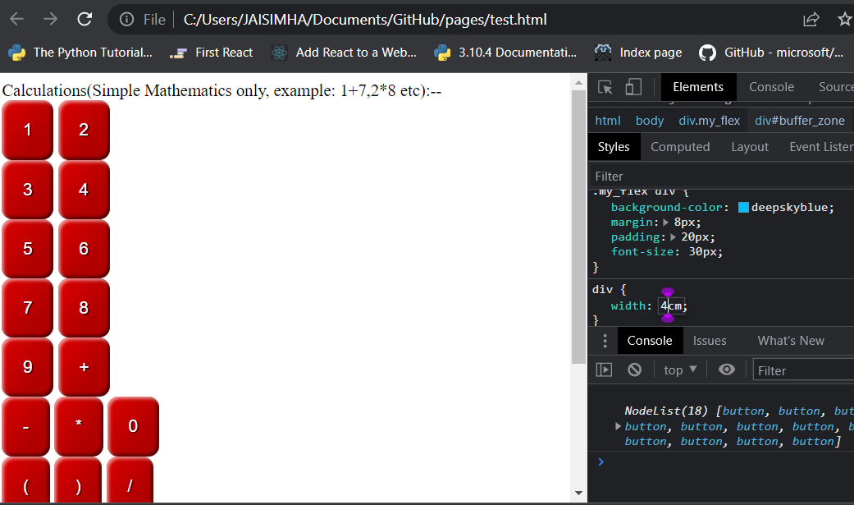

# 36 [(Nested Addevent listener)why does a AddEventListener click event act differently via an Arrow and normal function [duplicate]](https://stackoverflow.com/questions/75979037/nested-addevent-listenerwhy-does-a-addeventlistener-click-event-act-differentl)

**This question already has an answer here**:

[Javascript onclick function is called immediately (not when clicked)? [duplicate]](https://stackoverflow.com/questions/29526556/javascript-onclick-function-is-called-immediately-not-when-clicked) (1 answer)

Your post has been associated with a similar question. If that question doesn’t answer your issue, [edit your question](https://meta.stackexchange.com/questions/21788/how-does-editing-work) to highlight the difference between the associated question and yours. If edited, your question will be reviewed and might be reopened.  
  
**Find out more about**[**duplicates**](https://stackoverflow.com/help/duplicates)**and why your question**[**has been closed**](https://stackoverflow.com/help/closed-questions)**.**

Closed 9 days ago.

This post was edited and submitted for review 8 days ago and failed to reopen the post:

Original close reason(s) were not resolved

[Edit question](https://stackoverflow.com/posts/75979037/edit)Delete question

document.addEventListener("DOMContentLoaded", function() {

// Scenario 1

const btn = document.querySelector(".test");

btn.addEventListener("click", () => {

const fragment = document.createDocumentFragment();

var x = document.createElement('p');

x.className = "di";

x.style.background = "aqua";

for (var i = 1; i < 5; i++) {

x.textContent = ' Change background color for ' + `${i}` + " element";

x.id = 'para' + `${i}`;

fragment.append(x.cloneNode(true));

}

document.body.append(fragment);

//Nested addeventlistener

document.getElementById("para1").addEventListener("click", () => {

para1.style.background = "yellow"

});

document.getElementById("para2").addEventListener("click", () => {

para2.style.background = "yellow"

});

function changeBackgroundColor(elem) {

elem.style.background = "yellow";

}

//Nested addeventlistener

document.getElementById("para3").addEventListener("click", changeBackgroundColor(para3));

document.getElementById("para4").addEventListener("click", changeBackgroundColor(para4));

});

});

<button class="test">create 4 elements</button>

Step 1: Click on the HTML Button 'create 4 elements' to create 4 <p> elements.

Observation 1: for the **1st and 2nd <p> elements** which **have** arrow function inside their addeventlisteners , the individual <p> elements need to be explicitly clicked individually to change their background color from aqua to yellow.

Observation 2: for the **3rd and 4th <p>velements** which **dont** have arrow function inside their addeventlistener ,the background color has defaulted to yellow **without** clicking on the 3rd or 4th <p> elements

So does this mean the click event in Observation 2 has no effect ? Also note there are nested AddEventListeners

What is actionEventListener? They're just called event listeners, and addEventListener() adds them.

– [Barmar](https://stackoverflow.com/users/1491895/barmar)

[Apr 10 at 17:07](https://stackoverflow.com/questions/75979037/nested-addevent-listenerwhy-does-a-addeventlistener-click-event-act-differentl#comment134006071_75979037)

* 1

You're not passing a function reference, you're calling the function immediately.

– [Barmar](https://stackoverflow.com/users/1491895/barmar)

[Apr 10 at 17:08](https://stackoverflow.com/questions/75979037/nested-addevent-listenerwhy-does-a-addeventlistener-click-event-act-differentl#comment134006085_75979037)

* 1

addEventListener expects a function as 2nd parameter. changeBackgroundColor is a function, but changeBackgroundColor(param2) is equal to the value returned by executing that piece of code (undefined).

– [James](https://stackoverflow.com/users/535480/james)

[Apr 10 at 17:08](https://stackoverflow.com/questions/75979037/nested-addevent-listenerwhy-does-a-addeventlistener-click-event-act-differentl#comment134006091_75979037)

* @james so how to pass a param then?

– [Richard](https://stackoverflow.com/users/21245853/richard)

[Apr 10 at 17:52](https://stackoverflow.com/questions/75979037/nested-addevent-listenerwhy-does-a-addeventlistener-click-event-act-differentl#comment134006654_75979037)

* 1

Wrap it in an anon function, element.addEventListener("click", () => changeBackgroundColor(para3))

– [James](https://stackoverflow.com/users/535480/james)

[Apr 10 at 17:56](https://stackoverflow.com/questions/75979037/nested-addevent-listenerwhy-does-a-addeventlistener-click-event-act-differentl#comment134006717_75979037)

# 37 [How to render an array of document fragments?](https://stackoverflow.com/questions/75970763/how-to-render-an-array-of-document-fragments)

<https://stackoverflow.com/questions/75970763/how-to-render-an-array-of-document-fragments>

var fragment = [];

function create1() {

for (var i = 0; i < 5; i++) {

x = document.createElement('div');

x.className = "di";

x.textContent = 'Change background color';

fragment[i] = document.createDocumentFragment();

console.log(fragment[i]);

fragment[i].append(x.cloneNode(true));

}

document.body.append(fragment);

}

create1();

.di {

border: solid green 2px;

margin-right: 65em;

margin-top: 4px;

}

❌ leaked global variable x  
❌ unnecessary global fragment  
❌ functions don't take arguments or return values  
❌ poor function composition, separate concerns

Answer 1:

It doesn't make a lot of sense to create a DocumentFragment per element: a DocumentFragment can be very useful to collect multiple elements into a single group to append them all at once. Otherwise you could just append the element to the body directly without using the document fragment and get the same result. See the result below.

function create1() {

const fragment = document.createDocumentFragment();

const x = document.createElement('div');

x.className = "di";

x.textContent = 'Change background color';

for (let i = 0; i < 5; i++) {

fragment.append(x.cloneNode(true));

}

document.body.append(fragment);

}

create1();

.di {

border: solid green 2px;

margin-right: 65em;

margin-top: 4px;

}

Answer 2:  
function create1(n) {

const elem = Object.assign(

document.createElement(`div`),

{ className: `di`, textContent: `change background color` } );

const elems = Array.from({length: n}, _ => elem.cloneNode(true));

document.body.append(...elems);

}

create1(5);

.di {

border: solid green 2px;

max-width: 200px;

margin-top: 4px;

}

Answer 3:

var fragment = [];

function create1() {

for (var i = 0; i < 5; i++) {

x = document.createElement('div');

x.className = "di";

x.textContent = 'Change background color';

fragment[i] = document.createDocumentFragment();

fragment[i].append(x);

}

document.body.append(...fragment) // ✅ spread fragment

}

create1();

.di {

border: solid green 2px;

margin-right: 65em;

margin-top: 4px;

}

Answer 4:

function div(className = "", textContent = "") {

const e = document.createElement("div")

e.className = className

e.textContent = textContent

return e

}

function fragment(...children) {

const e = document.createDocumentFragment()

e.append(...children)

return e

}

function create(count = 0) {

const divs = [] // ✅ array of divs

for (let i = 0; i < count; i++) {

divs.push(

div("di", "change background color")

)

}

return fragment(...divs) // ✅ return single fragment

}

document.body.append(create(3)) // ✅ append single fragment

.di {

border: solid green 2px;

margin-right: 65em;

margin-top: 4px;

}

# 38. [adding elements using an array via appendChild](https://stackoverflow.com/questions/75968916/adding-elements-using-an-array-via-appendchild)

[Ask Question](https://stackoverflow.com/questions/ask)

var text = [];

function create() {

for (var i = 0; i < 4; i += 1) {

text[i] = document.createElement("div");

text[i].className = "di";

text[i].innerHTML = "hello world";

console.log(text[i]);

document.body.appendChild(text[i]);

}

}

create();

.di {

border: solid green 2px;

margin-right: 65em;

}

Save this answer.

The error

"TypeError: Cannot read properties of null (reading 'appendChild')"

occurs because the code is trying to append an element to a non-existent element or a *null* element.

In this case, it is possible that the JavaScript code is being executed before the DOM (Document Object Model) has finished loading, and the *document.body* element is not yet available. As a result, the document.body returns null, and the appendChild() method cannot be called on it.

To fix this error, you can either move the script tag to the end of the HTML file, just before the closing tag, or wrap the entire JavaScript code in a [DOMContentLoaded](https://developer.mozilla.org/en-US/docs/Web/API/Window/DOMContentLoaded_event) event listener, which will ensure that the code is executed only after the DOM has finished loading.

Try:

document.addEventListener("DOMContentLoaded", function() {

var text = [];

function create() {

for (var i = 0; i < 4; i += 1) {

text[i] = document.createElement("div");

text[i].className = "di";

text[i].innerHTML = "hello world";

console.log(text[i]);

document.body.appendChild(text[i]);

}

}

create();

});

# 39. [nbsp and css animation browser rendering issue](https://stackoverflow.com/questions/75805674/nbsp-and-css-animation-browser-rendering-issue)

[Ask Question](https://stackoverflow.com/questions/ask)

body {

background-color:#DFE1E1;

font-family:sans-serif;

margin-left:10%;

}

a:nth-child(n+1) {

color: black;

display:inline-block;

border:5px solid rebeccapurple;

overflow:hidden;

background: linear-gradient(0.25turn, #3f87a6, #ebf8e1, #f69d3c);

animation: animate 5s ease-in 1 forwards;

}

a:nth-child(1) {

border:5px solid yellow;

}

a:nth-child(2n+2) {

border:5px solid blue;

}

a:nth-child(2n+3) {

border:5px solid magenta;

}

@keyframes animate{

0%{

width: 0px;

}

100%{

width:290px;

}

}

<a>A for Apple</a>

<a>B&nbsp;for&nbsp;Blue</a>

Please observe the css animation between the **A for Apple** and **B for Blue** text elements, so initially the animation is not smooth(bumpy I should say) for the text content **A for Apple** but eventually they smoothen on a single line but in the **B for Blue** the css animation is very smooth right from the initial to final stages (if I introduce a nbsp html like: <a>B&nbsp;for&nbsp;Blue</a>) I actually dont want to use nbsp tags to avoid too much duplicacy in my html code, so please suggest alternative

ANSWER:

Are you talking about the line-wrapping? You could avoid it by adding [white-space: nowrap](https://developer.mozilla.org/en-US/docs/Web/CSS/white-space) to keep it all on one line.

The example below removes the nbsps and adds white-space: nowrap to the CSS.

body {

background-color:#DFE1E1;

font-family:sans-serif;

margin-left:10%;

}

a:nth-child(n+1) {

color: black;

display:inline-block;

border:5px solid rebeccapurple;

overflow:hidden;

background: linear-gradient(0.25turn, #3f87a6, #ebf8e1, #f69d3c);

animation: animate 5s ease-in 1 forwards;

white-space: nowrap;

}

a:nth-child(1) {

border:5px solid yellow;

}

a:nth-child(2n+2) {

border:5px solid blue;

}

a:nth-child(2n+3) {

border:5px solid magenta;

}

@keyframes animate{

0%{

width: 0px;

}

100%{

width:290px;

}

}

<a>A for Apple</a>

<a>B for Blue</a>

Perfect and accepted but why does the line-wrapping/bumpiness /jerkiness phenomenon appear in browsers if you can add the concept ?

– [Richard](https://stackoverflow.com/users/21245853/richard)

[Mar 22 at 3:23](https://stackoverflow.com/questions/75805674/nbsp-and-css-animation-browser-rendering-issue#comment133724141_75806153)   Delete

* great insight , also working good would be the [white-space: pre;](https://developer.mozilla.org/en-US/docs/Web/CSS/white-space)

– [Richard](https://stackoverflow.com/users/21245853/richard)

[Mar 22 at 3:49](https://stackoverflow.com/questions/75805674/nbsp-and-css-animation-browser-rendering-issue#comment133724287_75806153)

Text wraps by default because most of the time you want it to stay within the bounds of its container.

–

body {

background-color:#DFE1E1;

font-family:sans-serif;

margin-left:30%;

}

/*1st */

h1:nth-child(1) {

color: red;

border:5px solid rebeccapurple;

overflow:hidden;

animation: animate 5s ease-in 1 forwards;

}

/*2nd */

h1:nth-child(2) {

color: red;

border:5px solid blue;

overflow:hidden;

animation: animate 5s ease-in 1 forwards;

}

/*3rd */

h1:nth-child(3) {

color: red;

border:5px solid green;

overflow:hidden;

animation: animate 5s ease-in 1 forwards;

}

@keyframes animate{

0%{

width: 0;

}

100%{

width:250px;

}

}

<h1>A&nbsp;for&nbsp;Apple</h1>

<h1>B&nbsp;for&nbsp;Blue</h1>

<h1>C&nbsp;for&nbsp;Car</h1>

<h1>D&nbsp;for&nbsp;Doctor</h1>

<h1>E&nbsp;for&nbsp;Egg</h1>

<h1>F&nbsp;for&nbsp;Frog</h1>

<h1>G&nbsp;for&nbsp;Girl</h1>

 Run code snippet

Expand snippet

As you can observe I have mostly ended up duplicating my CSS Code in h1:nth-child tags other than the **border:5px solid ; tag** ,so can someone show an alternative way to reduce this nth of css code duplicacy .scenario would be like: nth code for A for apple will have a different border color, n+1 code for B for Boy will have some other different color tag so all in all 26 different border color tag

Answer1:

Just use comma , for remove CSS duplicates like this:

body {

background-color:#DFE1E1;

font-family:sans-serif;

margin-left:30%;

}

h1:nth-child(1), h1:nth-child(2), h1:nth-child(3) {

color: red;

overflow:hidden;

animation: animate 5s ease-in 1 forwards;

border: 5px solid;

}

/*1st */

h1:nth-child(1) {

border-color: rebeccapurple;

}

/*2nd */

h1:nth-child(2) {

border-color: blue;

}

/*3rd */

h1:nth-child(3) {

border-color: green;

}

@keyframes animate{

0%{

width: 0;

}

100%{

width:250px;

}

}

<h1>A&nbsp;for&nbsp;Apple</h1>

<h1>B&nbsp;for&nbsp;Blue</h1>

<h1>C&nbsp;for&nbsp;Car</h1>

<h1>D&nbsp;for&nbsp;Doctor</h1>

<h1>E&nbsp;for&nbsp;Egg</h1>

<h1>F&nbsp;for&nbsp;Frog</h1>

<h1>G&nbsp;for&nbsp;Girl</h1>

Or if you want simplify it again, you can use :nth-child(-n+3) to select the first 3 of the child element like this:

h1:nth-child(-n+3) {

color: red;

overflow:hidden;

animation: animate 5s ease-in 1 forwards;

border: 5px solid;

}

yes it works , I realised n+1 th selectors can be treated just as other css tags so comma can be used .Thanks

– [Richard](https://stackoverflow.com/users/21245853/richard)

[Mar 21 at 9:19](https://stackoverflow.com/questions/75799105/is-there-a-way-to-inherit-css-generic-code#comment133708787_75799161)   Delete

* for removing the &nbsp do you have any alternatives?the reason i put nbsp was due to rendering spill issue

– [Richard](https://stackoverflow.com/users/21245853/richard)

[Mar 21 at 9:23](https://stackoverflow.com/questions/75799105/is-there-a-way-to-inherit-css-generic-code#comment133708878_75799161)

* 1

I am not sure what you're trying to achieve there. What you could do would range from just using a space to wrapping the words you want in a <span> and apply left and right paddings, if that's what you're after.

– [Niccolò Mineo](https://stackoverflow.com/users/10899409/niccol%c3%b2-mineo)

[Mar 21 at 13:14](https://stackoverflow.com/questions/75799105/is-there-a-way-to-inherit-css-generic-code#comment133712762_75799161)

# 40. [What is the difference between Document and document?](https://stackoverflow.com/questions/75688637/what-is-the-difference-between-document-and-document)

[Ask Question](https://stackoverflow.com/questions/ask)

0

Refer link [Document.children](https://developer.mozilla.org/en-US/docs/Web/API/Document) where it says:

Document.children: Returns the child elements of the current document.

**and**

[document.children](https://developer.mozilla.org/en-US/docs/Web/API/Document/children) page where the code example is given as document.children;

So why the minor difference between the code **syntax** between Caps D in Document.children compared to small case **d** in document.children

ANSWER 1:

* Document (with a capital "D") refers to the interface.
* document (with a lower-case "d") refers to the object that implements the interface.

So, in code, you'd use document.

If you are unfamiliar with "interface" vs. "implementation", you can think of it like this...

A Honda Civic and a Lamborghini both can have a manual transmission "interface", but the way that this interface is implemented in each vehicle "object" may differ. So the interface is "manual transmission", but the objects that implement that interface are "Honda Civic" and "Lamborghini".

In the case of the Document Object Model, the "document" object implements the "Document" interface.

# 41. [What does querySelector() do when not called on the document?](https://stackoverflow.com/questions/75656152/what-does-queryselector-do-when-not-called-on-the-document)

[Ask Question](https://stackoverflow.com/questions/ask)

n the [MDN template docs](https://developer.mozilla.org/en-US/docs/Web/HTML/Element/template) I saw code as clone.querySelectorAll("td");, so out of curiosity I wrote JS code snippet as document.querySelector(".para").append(" hello");h5.querySelector(".para").append(" world") to try to append 'world' to 'hello', but got an error.

Please explain the concept of a non-document(dot)querySelector style and its usage to rectify my error

h5=document.createElement('h5');

h5.textContent= "text updated";

h5.className= "first";

document.querySelector(".para").append(" hello");//works

h5.querySelector(".para").append(" world");//console log error of value null meaning nothing selected

<p class="para"> Test: </p>

Answer 1:

Calling querySelector() on an element restricts the search to the element's descendants, rather than searching the entire DOM.

You need to insert a <p class="para"> inside the <h5> so it will be found. And if you want to see the results, you need to append h5 to the document.

let h5=document.createElement('h5');

let p = document.createElement('p');

p.textContent = 'Test2:';

p.classList.add('para');

h5.appendChild(p);

document.body.appendChild(h5);

h5.className= "first";

document.querySelector(".para").append(" hello");//works

h5.querySelector(".para").append(" world");

<p class="para"> Test: </p>

# 42. [Usage of comment node in javascript](https://stackoverflow.com/questions/75645300/usage-of-comment-node-in-javascript)

[Ask Question](https://stackoverflow.com/questions/ask)

his is just a representation of HTML <!-- Test --> and it can be inserted in your document if so desired.

Why would you do this? Nobody knows for sure. Would you ever do this? Maybe not!

Why does it exist? Without this, there'd be parts of the DOM that could not be represented in the JavaScript domain, which would mean that there's holes in the API. It's for the sake of completeness. Every HTML element has a corresponding JavaScript representation by design.

You mentioned 'it can be inserted in your document if so desired'...then what are you referring as the 'it' ...is it <!-- Test --> or something else if you can elaborate ..thanks

– [Richard](https://stackoverflow.com/users/21245853/richard)

[Mar 5 at 21:07](https://stackoverflow.com/questions/75645300/usage-of-comment-node-in-javascript#comment133453693_75645317)

* 1

Well, they're one and the same, really. The JavaScript [Comment](https://developer.mozilla.org/en-US/docs/Web/API/Comment/Comment) node is inserted as the HTML <!-- ... --> accordingly, and any document with that kind of HTML will show up as a Comment in the JavaScript realm. They are, effectively, two different representations of the exact same thing.

– [tadman](https://stackoverflow.com/users/87189/tadman)

[Mar 5 at 21:08](https://stackoverflow.com/questions/75645300/usage-of-comment-node-in-javascript#comment133453703_75645317)

* 1

You can add this to your document as you would any other DOM element, like [Document.append()](https://developer.mozilla.org/en-US/docs/Web/API/Document/append). You can also find them when navigating through an existing document that has comments in it.

– [tadman](https://stackoverflow.com/users/87189/tadman)

[Mar 5 at 21:09](https://stackoverflow.com/questions/75645300/usage-of-comment-node-in-javascript#comment133453711_75645317)

* 1

accepted ; code example: <html> <body> <p id="p2">xxnode</p> </body> <script> let comment = new Comment("89876Test"); document.getElementById("p2").append(comment.data); </script> </html>

– [Richard](https://stackoverflow.com/users/21245853/richard)

[Mar 5 at 21:47](https://stackoverflow.com/questions/75645300/usage-of-comment-node-in-javascript#comment133454078_75645317)

* by the way ..Also comment shows up in console.log as <!--89876Test--> if console.log(comment) is written.

– [Richard](https://stackoverflow.com/users/21245853/richard)

[Mar 6 at 7:21](https://stackoverflow.com/questions/75645300/usage-of-comment-node-in-javascript#comment133458342_75645317)

# 43. [I am unable to append multiple times using the createdocumentfragment JS call](https://stackoverflow.com/questions/75506103/i-am-unable-to-append-multiple-times-using-the-createdocumentfragment-js-call)

const btn = document.querySelector(".test");

btn.addEventListener("click", () => {

a1 = document.createElement('h5');

a1.className = "bluecolor";

a1.innerHTML = 'Blue updated';

console.log(a1); //console log output is <h5 class="first">Blue updated.</h5>

document.getElementById('position').innerText = null; //clear the position

fragment = document.createDocumentFragment(); //create fragment

fragment.append(a1); //append a1 element to the fragment,works 1st time only

fragment.append(a1); //append a1 element to the fragment

fragment.append(a1); //append a1 element to the fragment

fragment.append(a1); //append a1 element to the fragment

fragment.append(a1); //append a1 element to the fragment

document.getElementById('position').append(fragment); //append the fragment to the DOM tree

});

.first,

.test {

color: bluecolor;

}

<h5 id="position">Text to be replaced</h5>

<button class="test">blue</button>

 Run code snippet

const btn = document.querySelector(".test");

btn.addEventListener("click", () => {

a1 = document.createElement('h5');

a1.className = "bluecolor";

a1.innerHTML = 'Blue updated';

console.log(a1); //console log output is <h5 class="first">Blue updated.</h5>

document.getElementById('position').innerText = null; //clear the position

fragment = document.createDocumentFragment(); //create fragment

fragment.append(a1); //append a1 element to the fragment,works 1st time only

fragment.append(a1); //append a1 element to the fragment

fragment.append(a1); //append a1 element to the fragment

fragment.append(a1); //append a1 element to the fragment

fragment.append(a1); //append a1 element to the fragment

document.getElementById('position').append(fragment); //append the fragment to the DOM tree

});

.first,

.test {

color: bluecolor;

}

<h5 id="position">Text to be replaced</h5>

<button class="test">blue</button>

 Run code snippet

Expand snippet

Upon clicking the 'blue' button, I wanna display the text 'Blue color updated' 5 times at once using the [createdocumentfragmentAPI](https://developer.mozilla.org/en-US/docs/Web/API/Document/createDocumentFragment) but the text 'Blue color updated' updates 1 time only even though I am trying to use the below process mentioned in the createdocumentfragment docs:

**The usual use case is to create the document fragment, append elements to the document fragment and then append the document fragment to the DOM tree. In the DOM tree, the document fragment is replaced by all its children. ** so where am I am going conceptually wrong , please explain

ANSWER 1:

This is the way the DOM works. If you append an existing element that is already in the DOM (or in this case a DOM fragment) in another place, the element is moved, not copied.

You would need to create new elements if you wish to insert them in a different place.

Other are already explain issue.\

Use cloneNode property to clone your existing element.

const btn = document.querySelector(".test");

btn.addEventListener("click", () => {

a1 = document.createElement('h5');

a1.className = "bluecolor";

a1.innerHTML = 'Blue updated';

console.log(a1); //console log output is <h5 class="first">Blue updated.</h5>

document.getElementById('position').innerText = null; //clear the position

fragment = document.createDocumentFragment(); //create fragment

fragment.append(a1.cloneNode(true)); //append a1 element to the fragment,works 1st time only

fragment.append(a1.cloneNode(true)); //append a1 element to the fragment

fragment.append(a1.cloneNode(true)); //append a1 element to the fragment

fragment.append(a1.cloneNode(true)); //append a1 element to the fragment

fragment.append(a1.cloneNode(true)); //append a1 element to the fragment

document.getElementById('position').append(fragment); //append the fragment to the DOM tree

});

<h5 id="position">Text to be replaced</h5>

<button class="test">blue</button>

# 44. [Styles elements generated via createElement](https://stackoverflow.com/questions/75502224/styles-elements-generated-via-createelement)

[Ask Question](https://stackoverflow.com/questions/ask)

1

Issue is: after hitting the button on the HTML page, the html <h5> tag text changes on the page but the <h5> tag text color wont change to blue (expected behavior as CSS style doesn't reload after clicking the button).  
What could be a possible workaround for solving this issue?

const btn = document.querySelector(".test");

btn.addEventListener("click", () => {

a1 = document.createElement('h5');

a1.className = "first";

a1.textContent = 'Blue updated.';

document.getElementById('position').innerHTML = a1.innerText;

//newtext = document.createTextNode('abc');

});

.test {

color: blue;

}

.first {

color: blue;

}

<h5 id="position">Text Color to be replaced to blue after hitting Blue button(but not happening)</h5>

<button class="test">Change to blue</button>

 Run code snippet

Expand snippet

Above, after the button is clicked and the action listener is triggered, the HTML <h5> tag elements code are created with a1 = document.createElement('h5'); a1.className = "first" The new text is displayed but the **color didn't change** (to blue).

ANSWER1:

You're inserting only the textContent instead of [appending](https://developer.mozilla.org/en-US/docs/Web/API/Element/append) the entire new H5 element

const btn = document.querySelector(".test");

const pos = document.querySelector('#position');

btn.addEventListener("click", () => {

const h5 = document.createElement('h5');

h5.className = "first";

h5.textContent = 'Blue updated.';

pos.innerHTML = ""; // Empty

pos.append(h5); // Append!

});

.test, .first { color: blue; }

<h5 id="position">Text Color to be replaced to blue after hitting Blue button(but not happening)</h5>

<button class="test">Change to blue</button>

 Run code snippet

Expand snippet

PS: You can also create some nifty reusable functions to handle the DOM querying and creation of elements, using a friendly syntax:

// DOM utility functions:

const el = (sel, par) => (par || document).querySelector(sel);

const elNew = (tag, prop) => Object.assign(document.createElement(tag), prop);

// Example:

const elPos = el('#position');

el(".test").addEventListener("click", () => {

const elH5 = elNew('H5', {

textContent: "Blue updated",

className: "first",

});

elPos.innerHTML = ""; // Empty

elPos.append(elH5); // Append!

});

.test, .first { color: blue; }

<h5 id="position">Text Color to be replaced to blue after hitting Blue button(but not happening)</h5>

<button class="test">Change to blue</button>

@Richard I cannot understand what and why you have that function e31 and what's supposed to actually do, sorry. I overall don't understand your follow-up question. Also don't pollute the global scope by using uninitialized variables like p5=, p6= etc. Always use const or let. Find some good tutorial about the basics of the JavaScript language: [Introduction to JS](https://developer.mozilla.org/en-US/docs/Learn/Getting_started_with_the_web/JavaScript_basics)

– [Roko C. Buljan](https://stackoverflow.com/users/383904/roko-c-buljan)

[Mar 9 at 22:56](https://stackoverflow.com/questions/75502224/styles-elements-generated-via-createelement#comment133530719_75502260)

* 1

In your above code, you're missing the understanding in the difference between Regular functions and - Arrow functions and their implicit return functionality. Find the difference about the two in the MDN Docs. It should be like: const e31=(x1,x2) => { return x1.querySelector(x2);} or **implicit return** like const e31=(x1,x2) => x1.querySelector(x2);

– [Roko C. Buljan](https://stackoverflow.com/users/383904/roko-c-buljan)

[Mar 9 at 23:05](https://stackoverflow.com/questions/75502224/styles-elements-generated-via-createelement#comment133530794_75502260)

# 45. [I am unable to see addEventListener event in dev tools MicrosoftEdge Version 112.0.1722.34 (Official build) (64-bit)](https://stackoverflow.com/questions/75989614/i-am-unable-to-see-addeventlistener-event-in-dev-tools-microsoftedge-version-112)

let x = document.createElement('p');

x.style.background = "aqua";

x.textContent = ' Click inside the box to Change background color ';

x.id = "para1";

console.log(x);

document.body.appendChild(x);

function changeBackgroundColor(evt) {

evt.currentTarget.style.background = "yellow";

}

debugger;

document.getElementById("para1").addEventListener("click", changeBackgroundColor);

p {

border: solid green 2px;

/*margin-right: 65em;*/

margin-top: 24px;

}

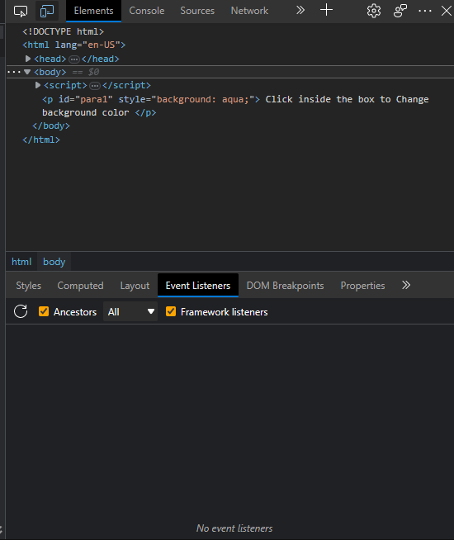

ANSWER 1:

The event is attached to an element. If you select this element then you can see its event handlers. You don't have to pause the code for that.

